**NAME: BALAJI M**

**REG. No.: 19BCE1512**

**Digital Assignment 1**

**HTML Tutorial**

**Faculty name:** Dr. SANDHYA P

**Course code:** CSE3002 – Internet and Web Programming

**Semester:** Fall 2020-2021

**OUTPUT SCREENSHOTS OF ALL WEB PAGES:**

**1.Login Page:**

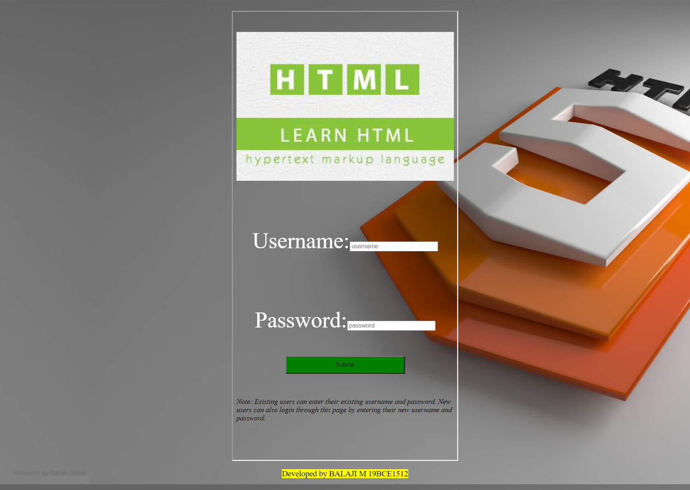

**2. Contents page:**

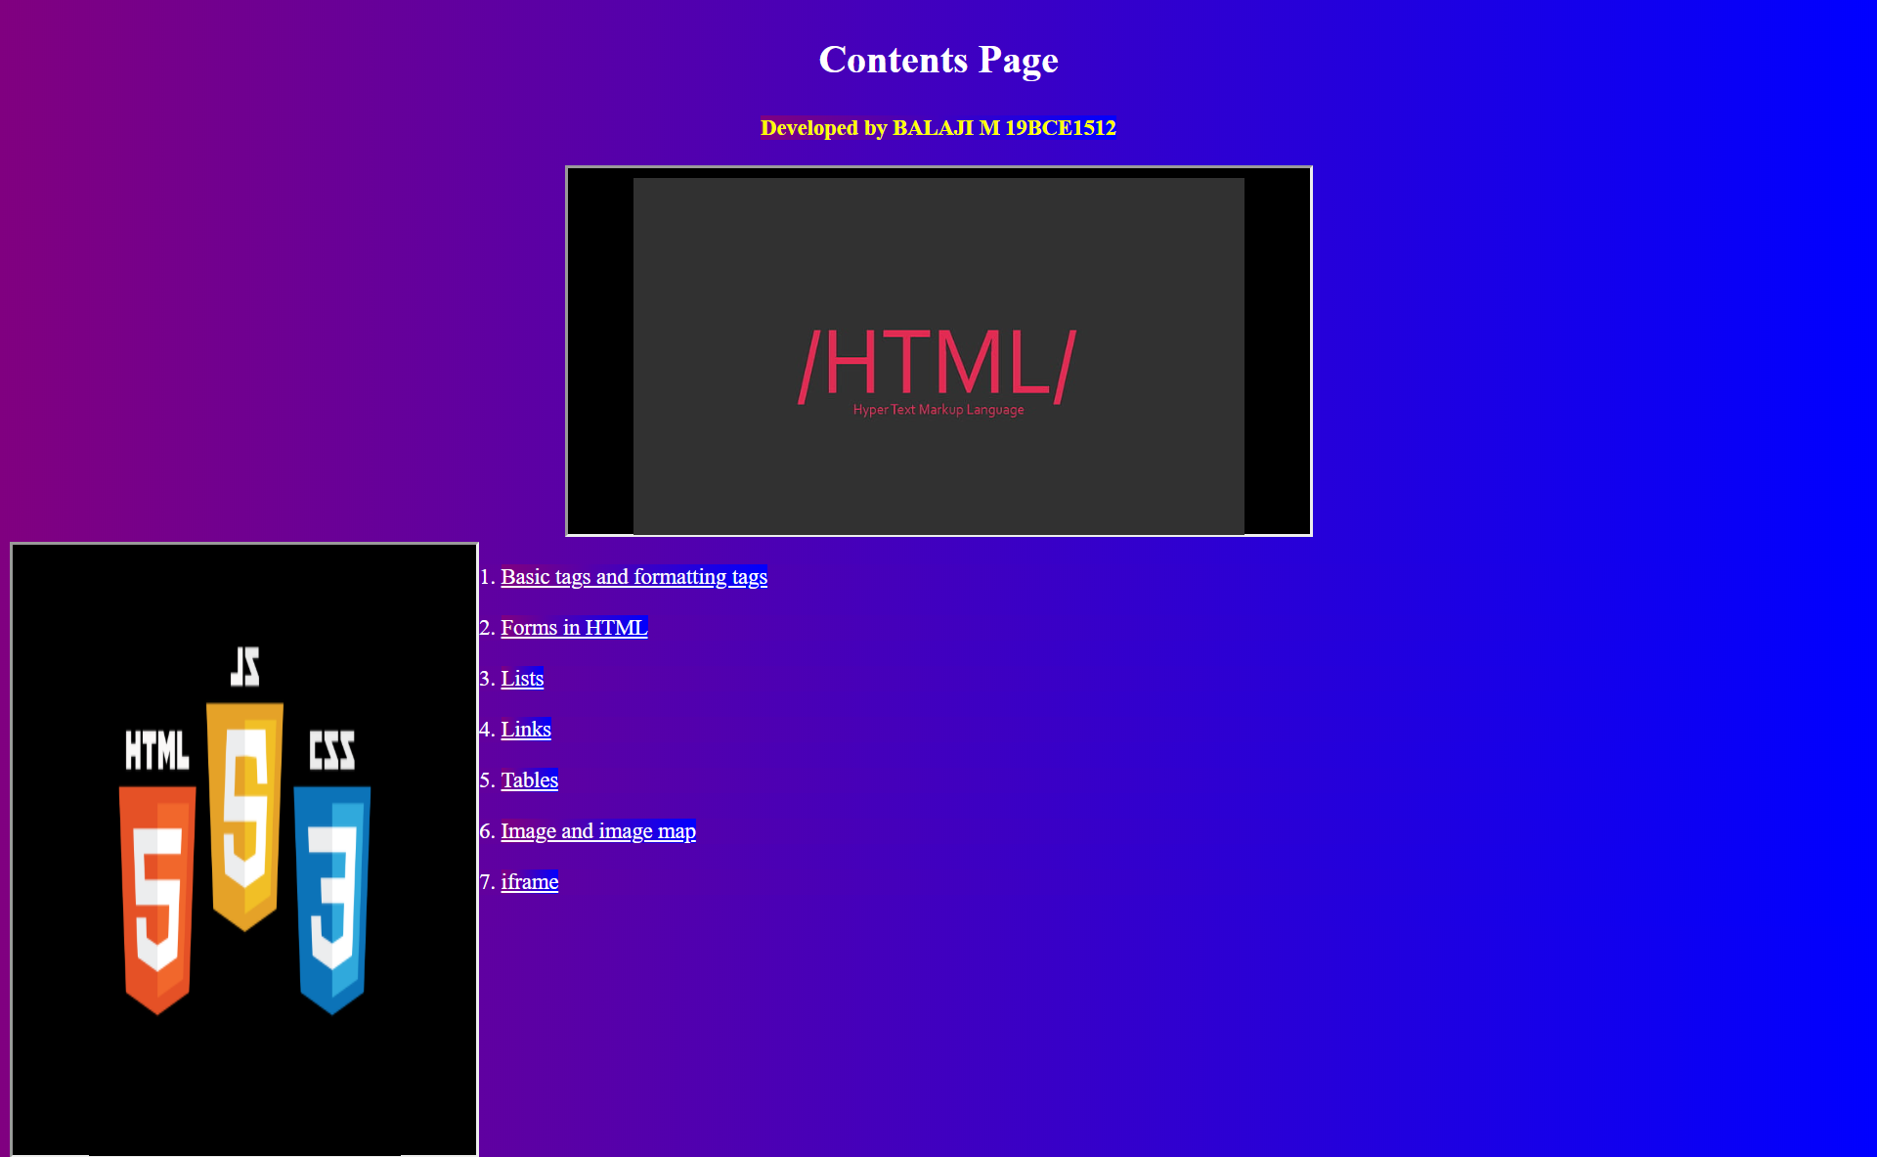

**3. Tutorial and explanation page:**

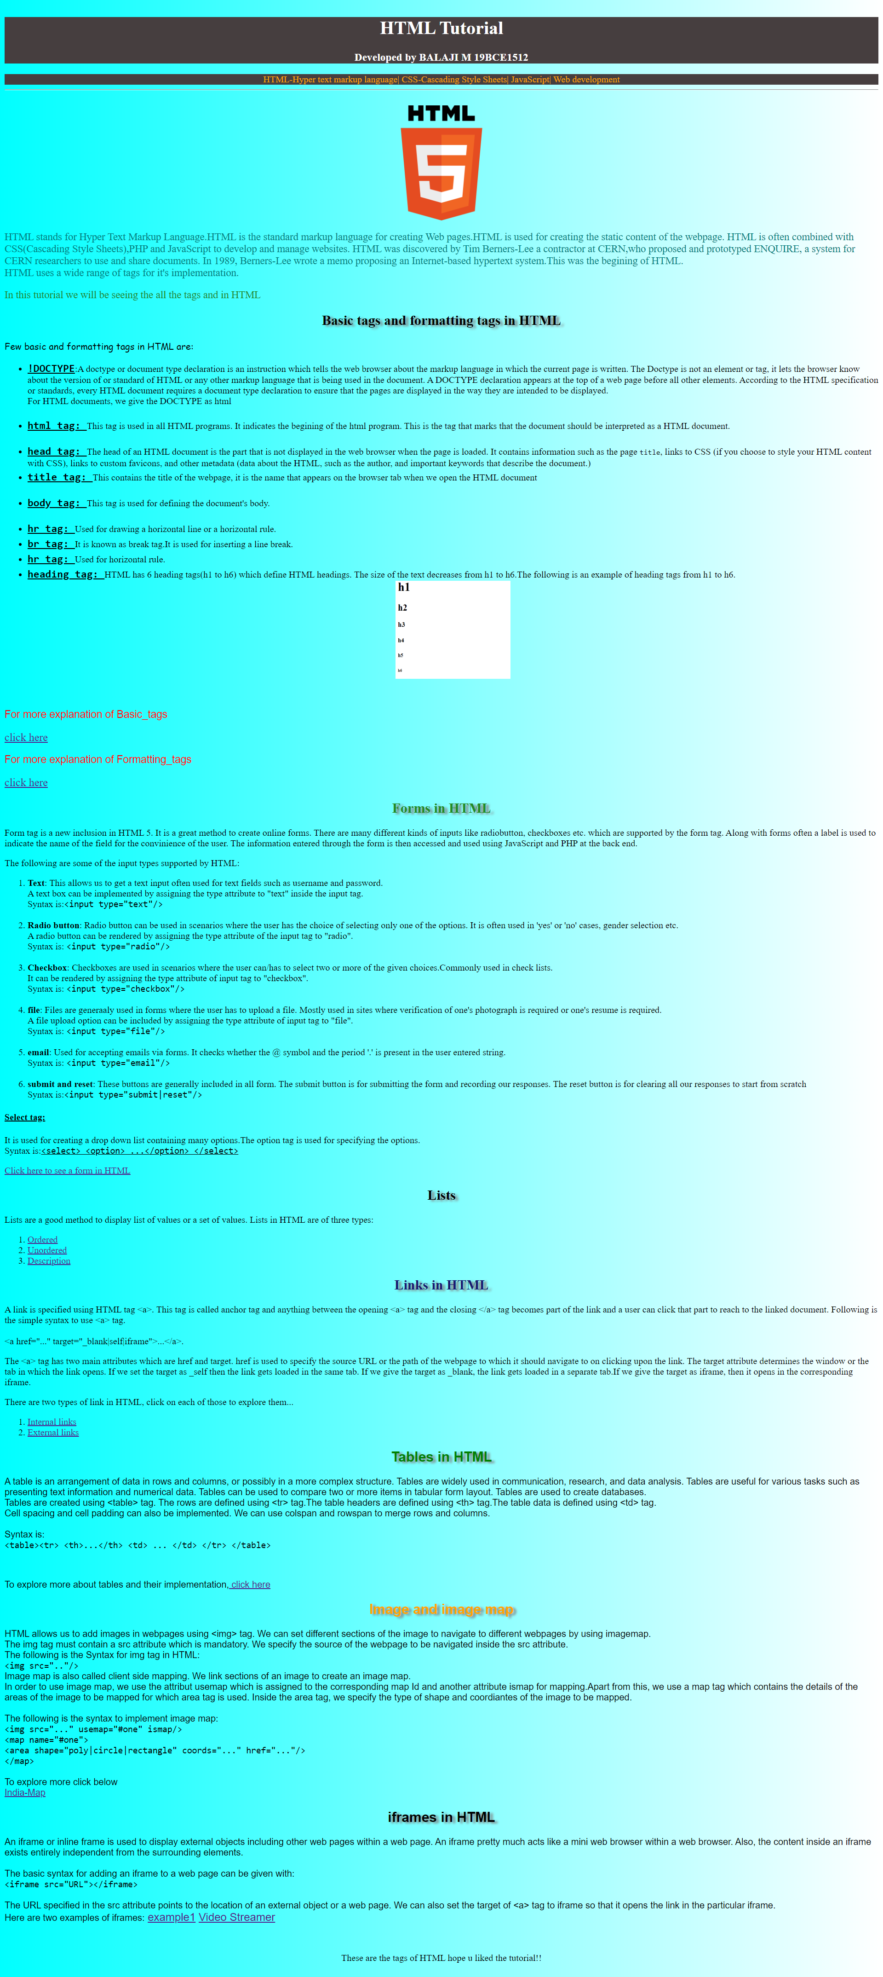

Zoomed in Screenshots:

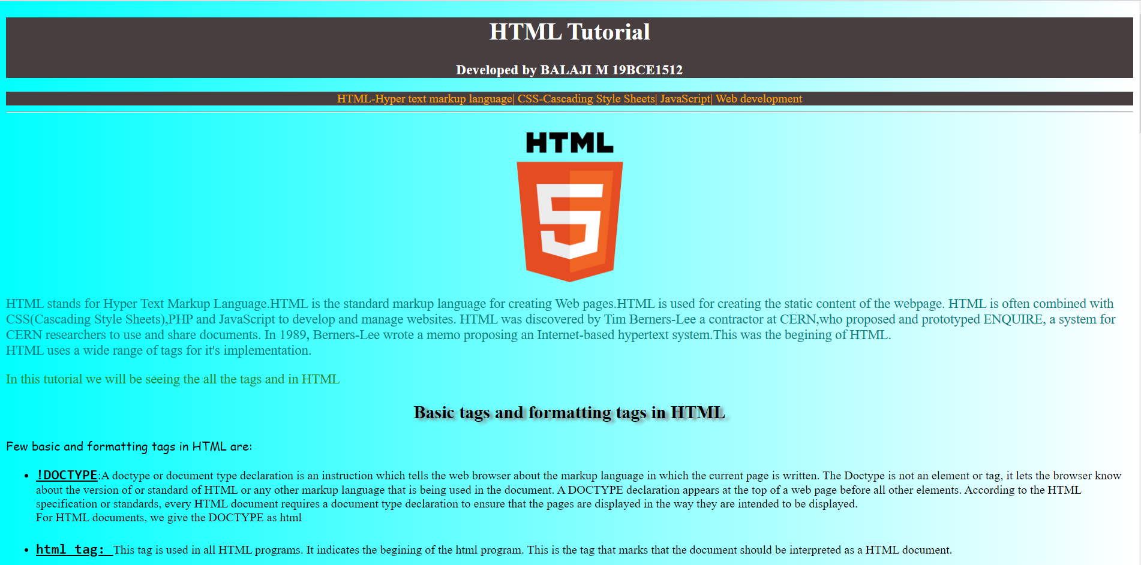

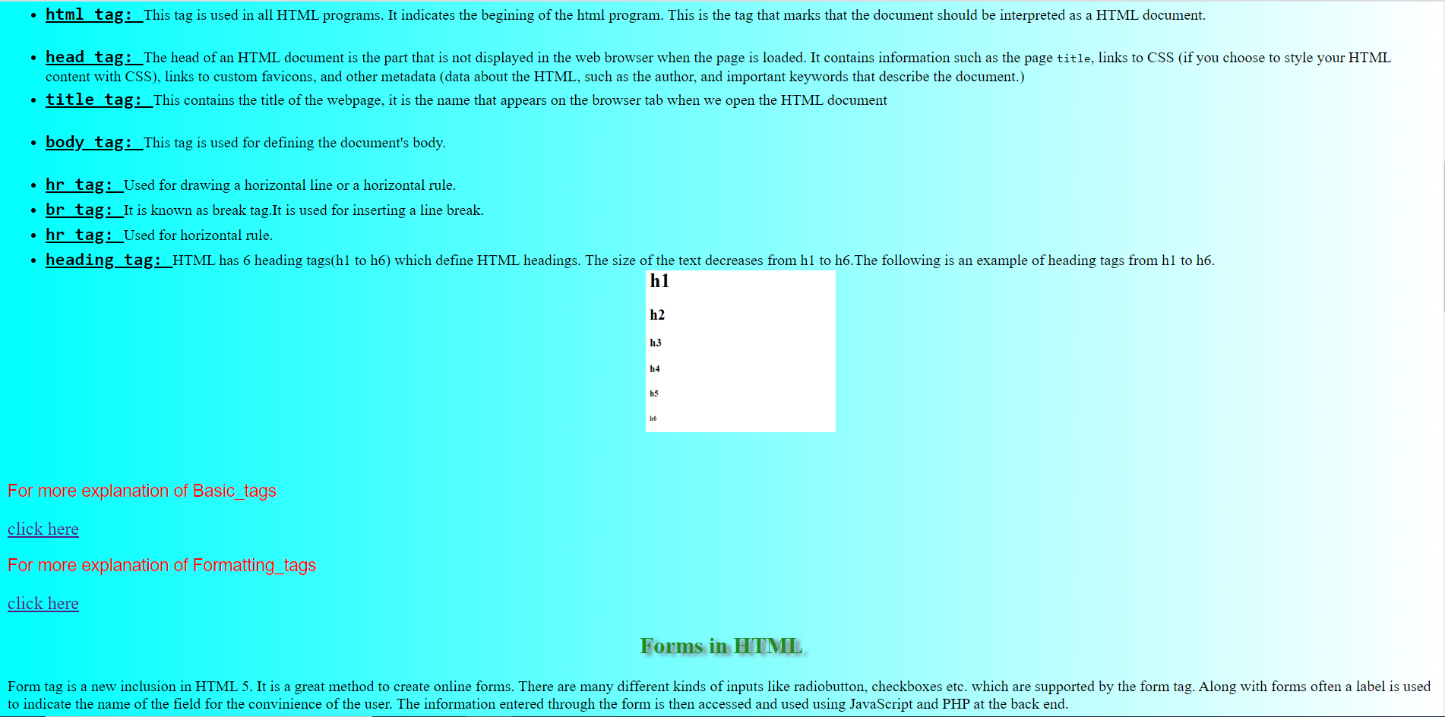

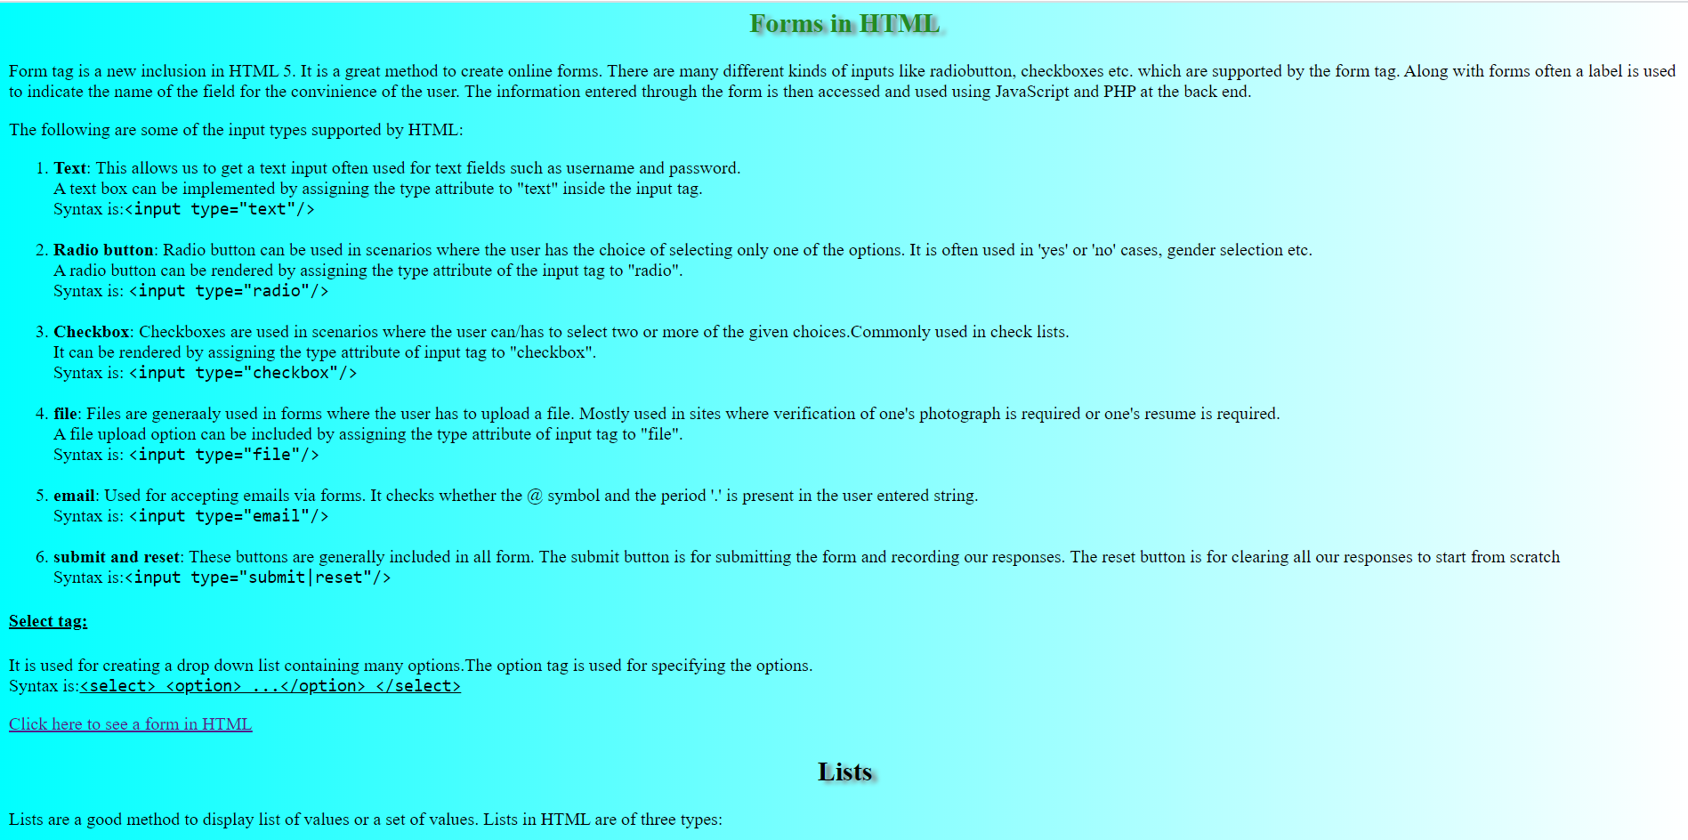

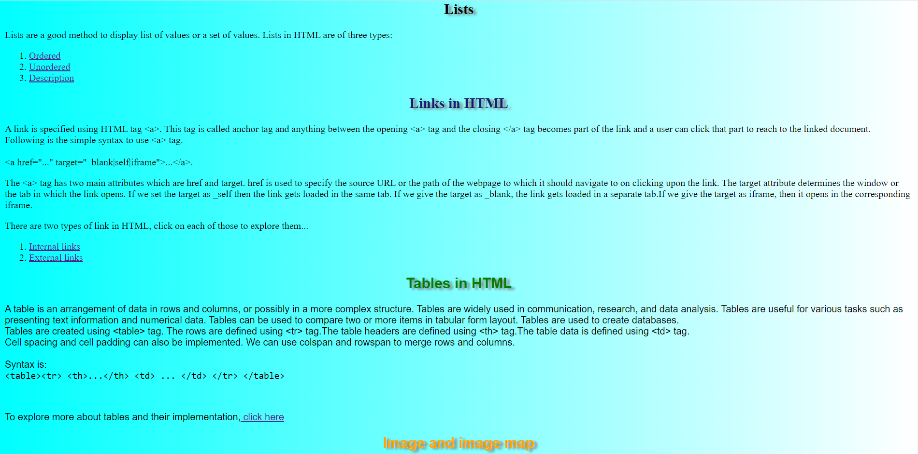

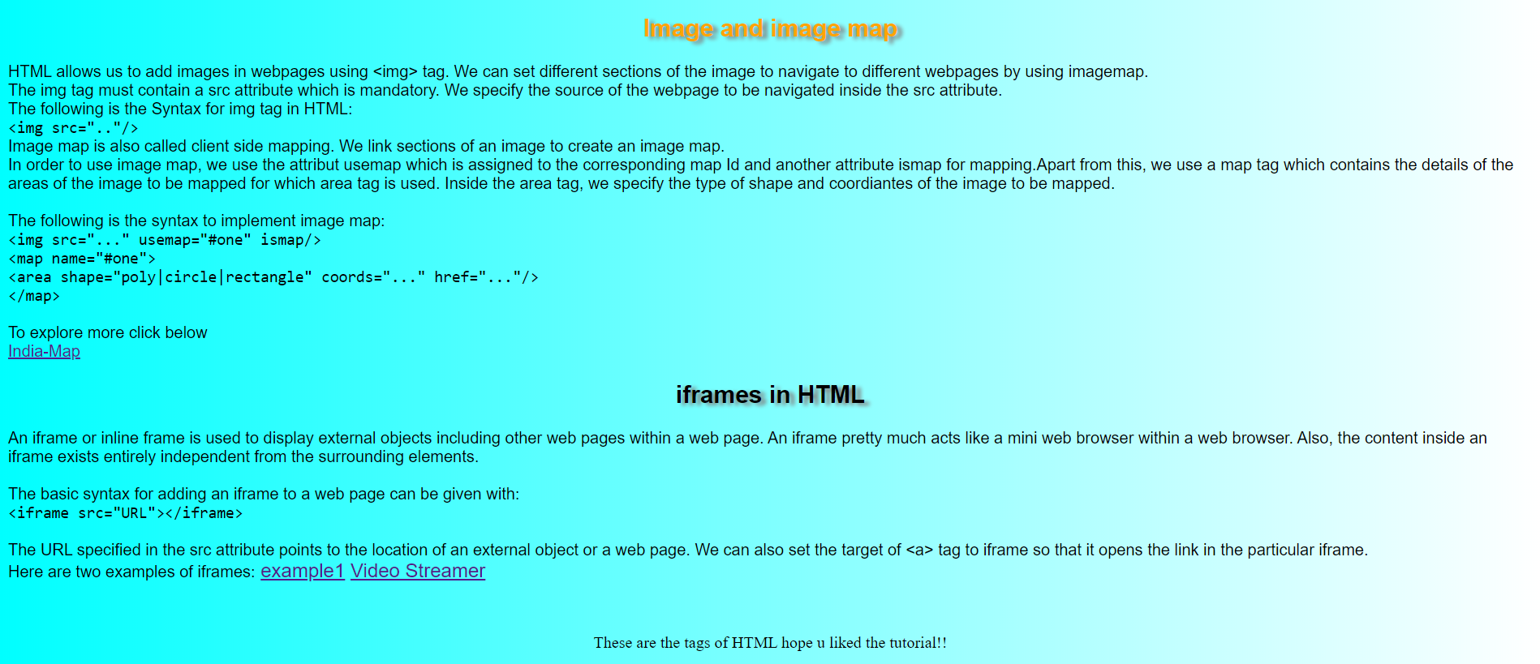

**4.Basic tags:**

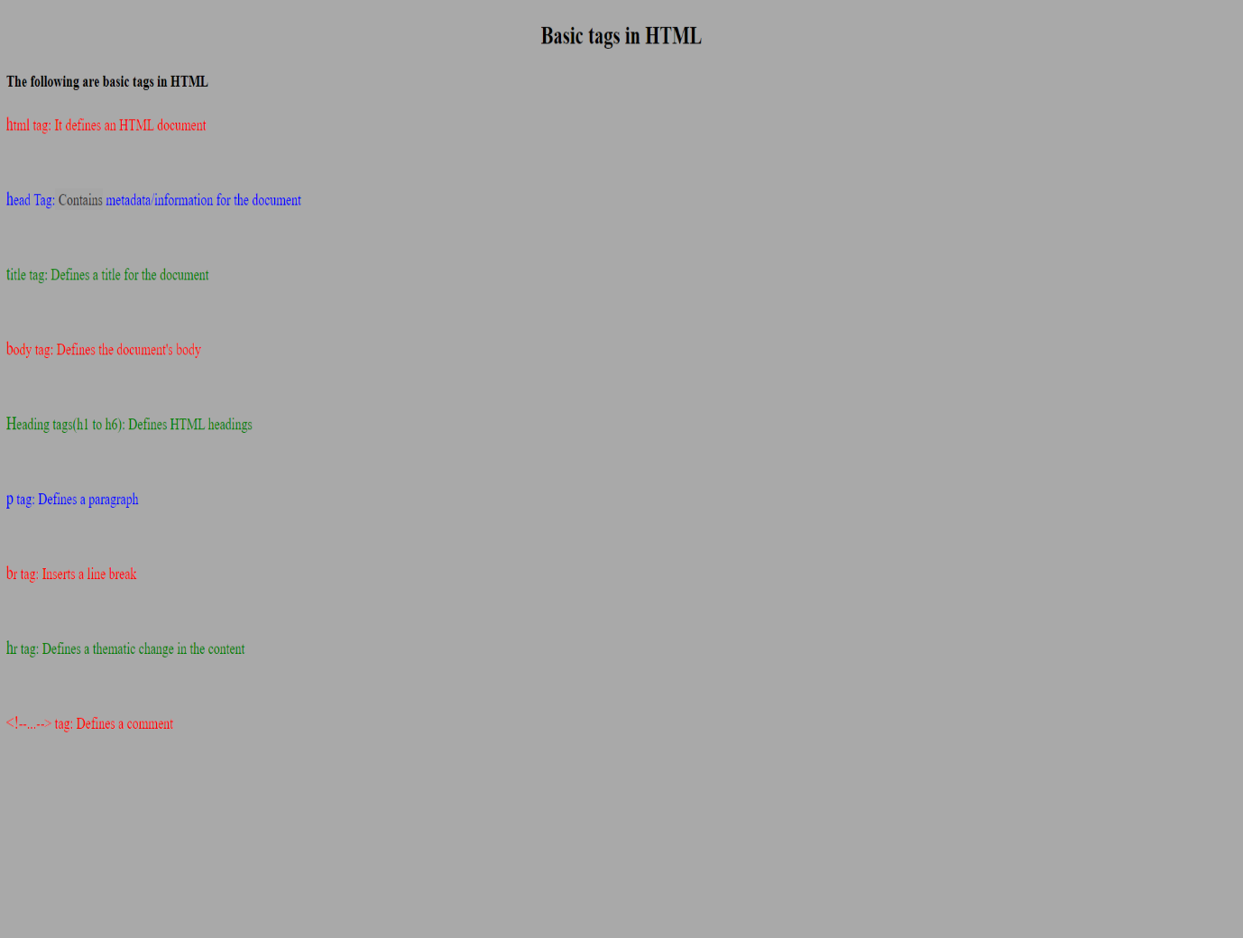

**5.Formatting tags:**

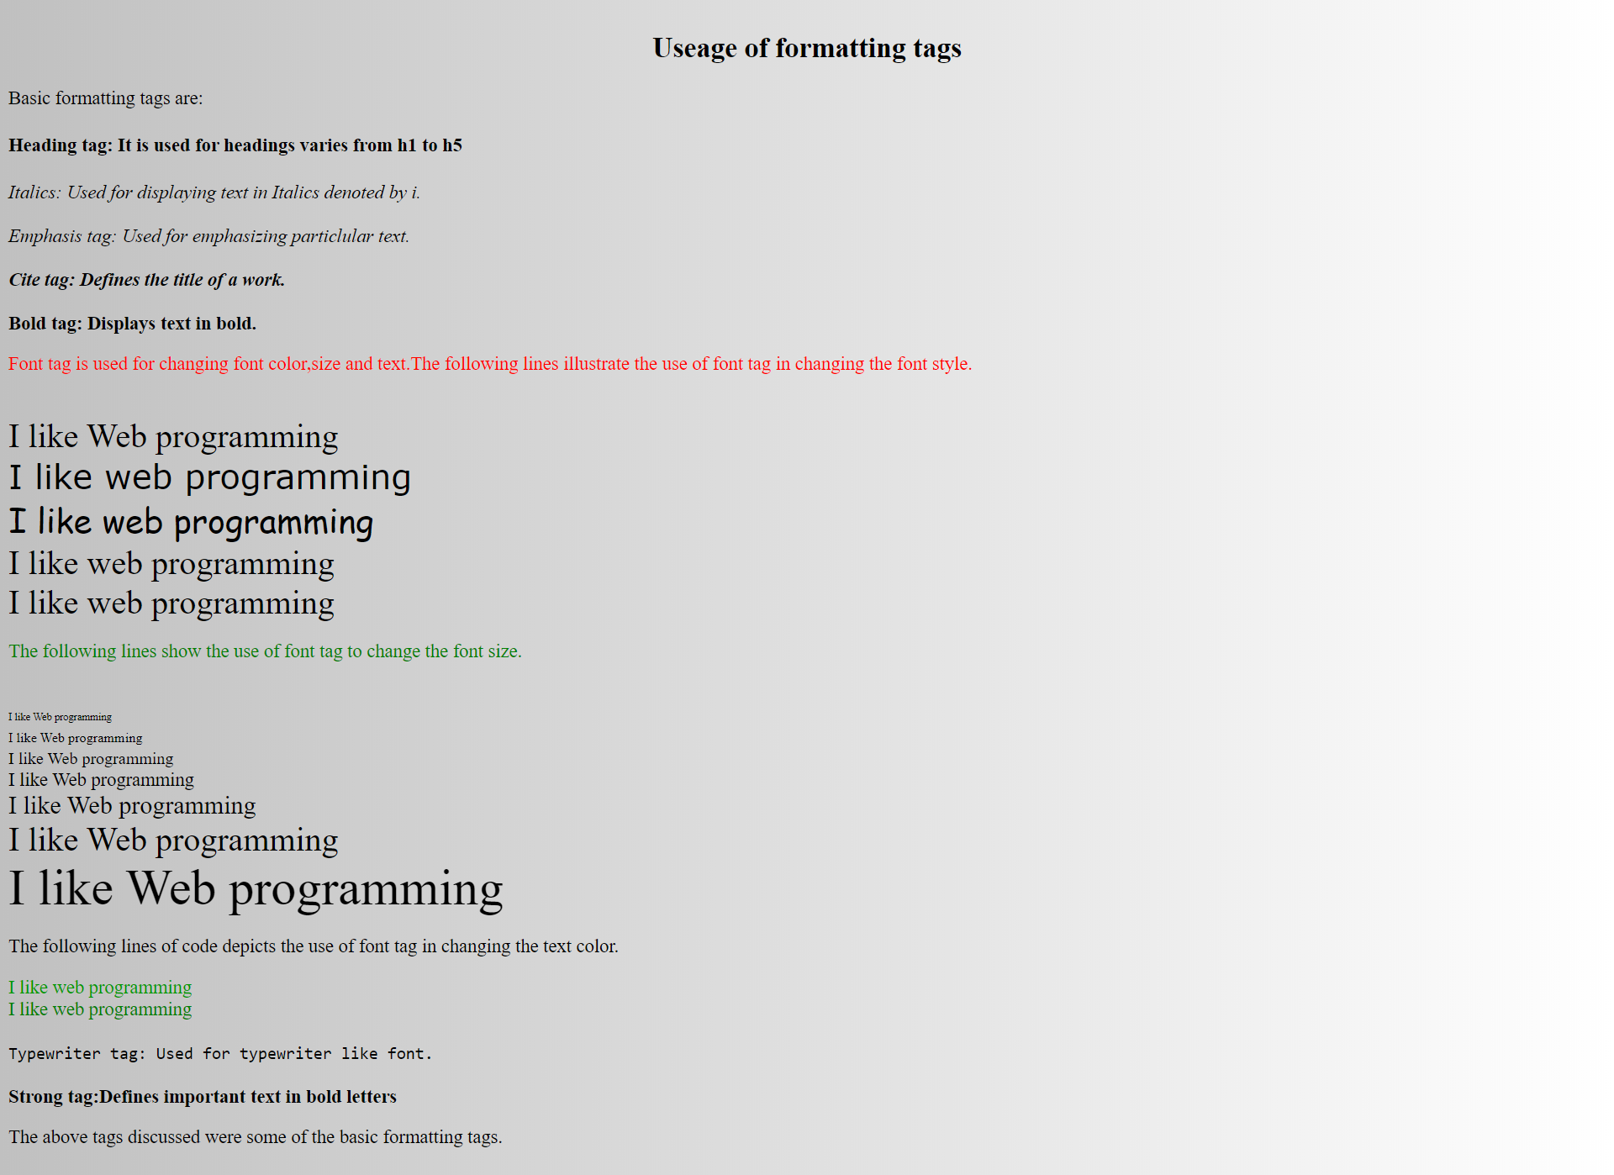

**6.Forms:**

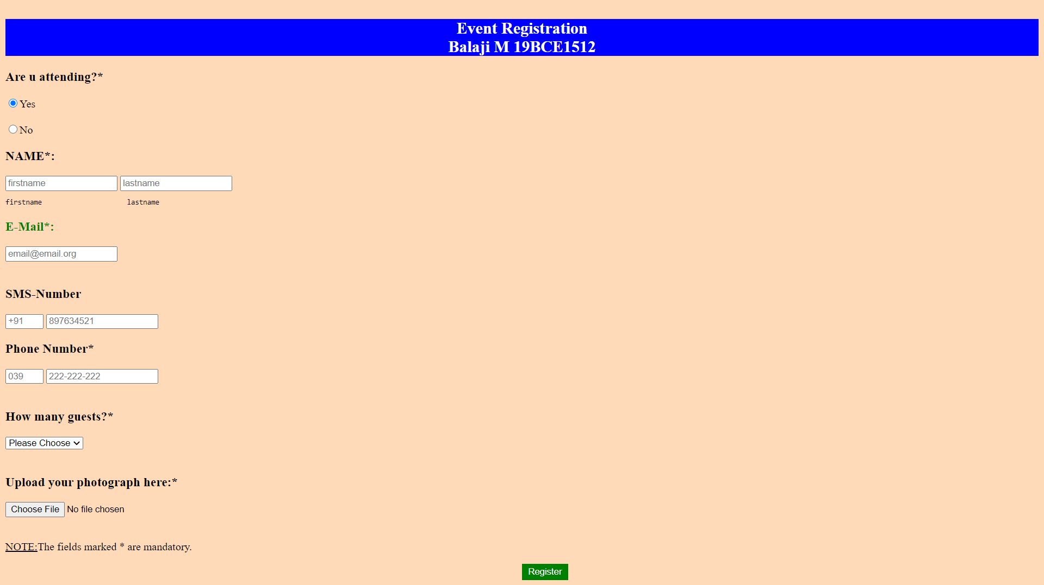

**7. Lists**

**7.1 Unordered lists:**

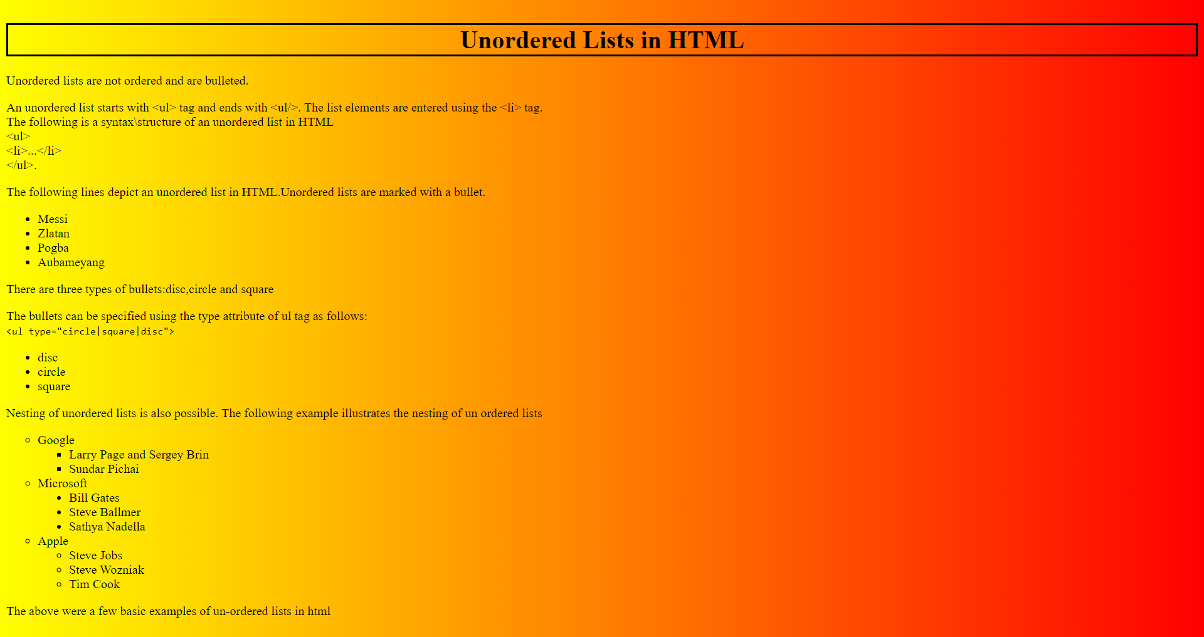

**7.2 Ordered lists:**

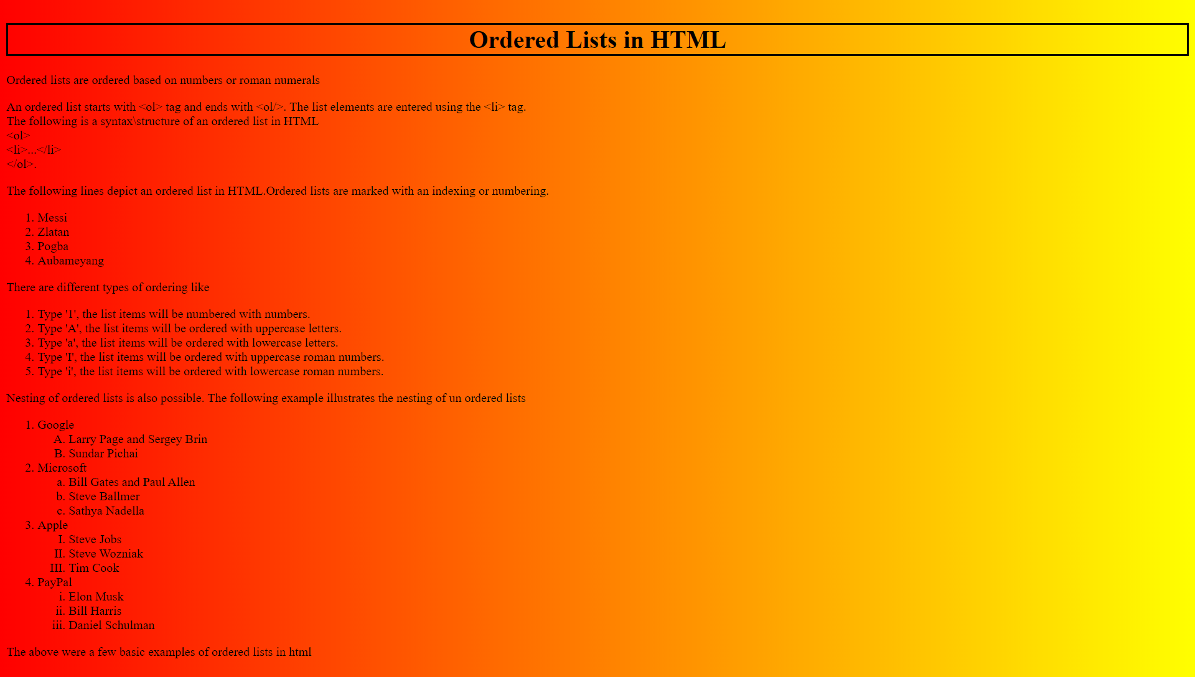

**7.3 Definition lists/description lists:**

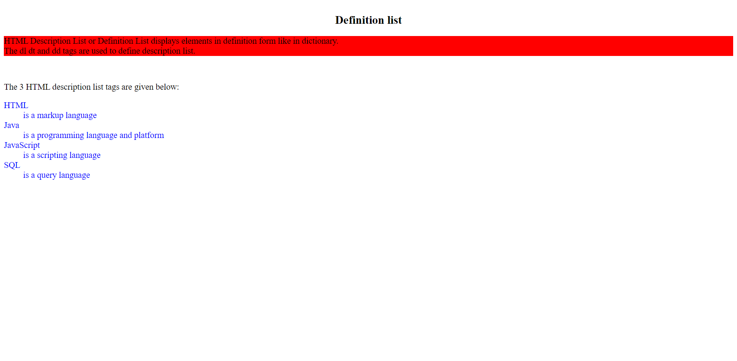

**8.Links in HTML:**

**8.1 Internal links:**

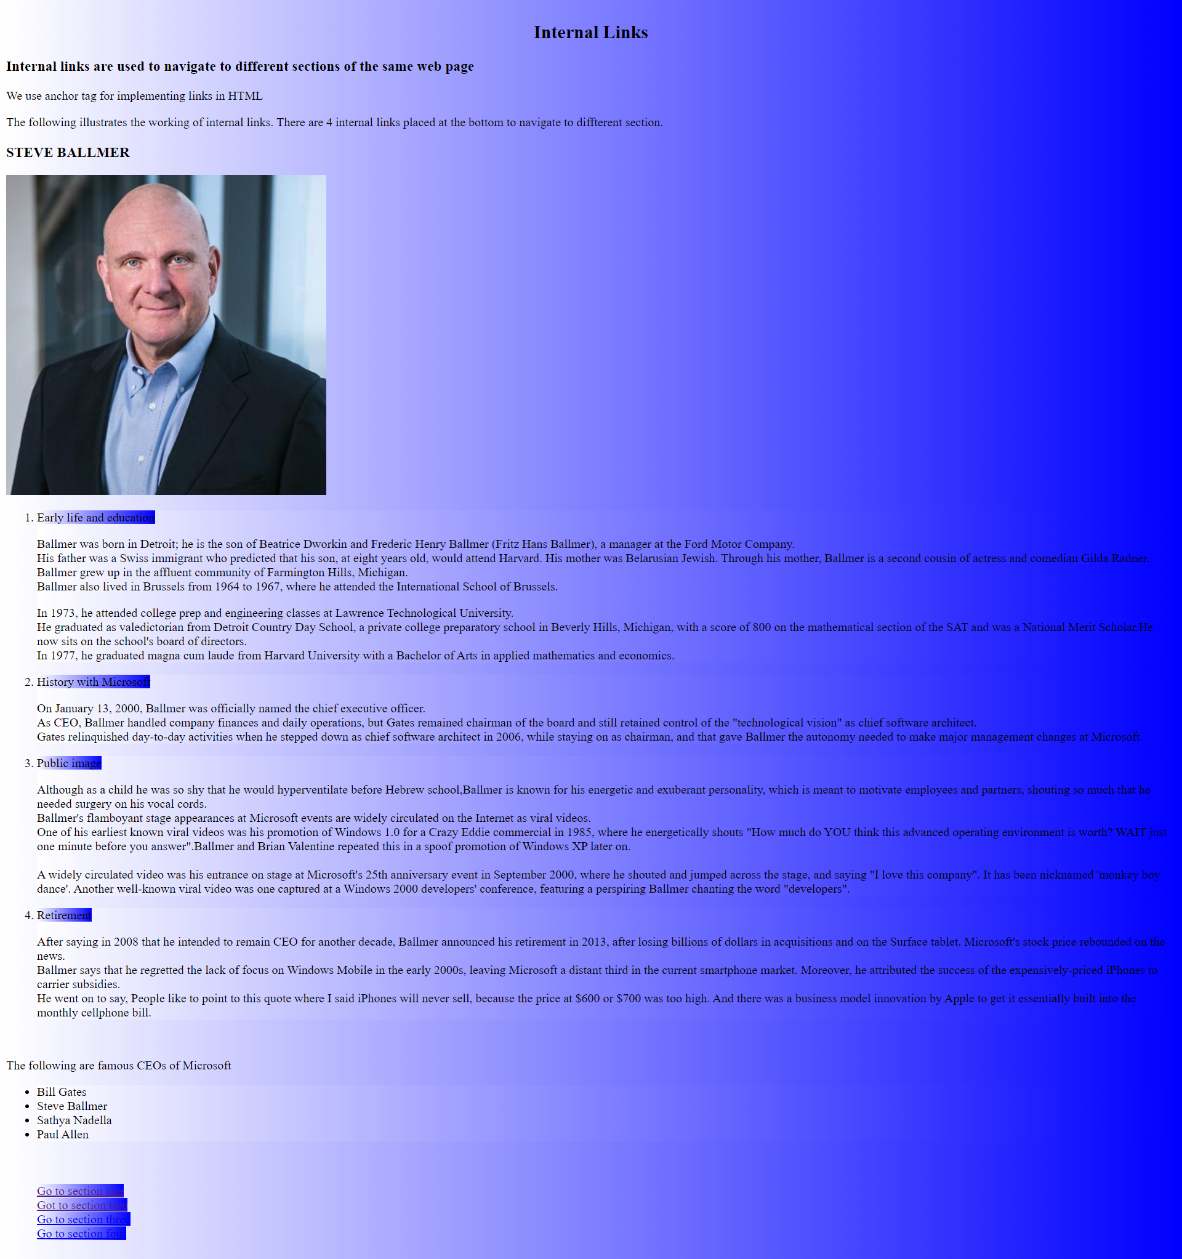

**8.2 External links:**

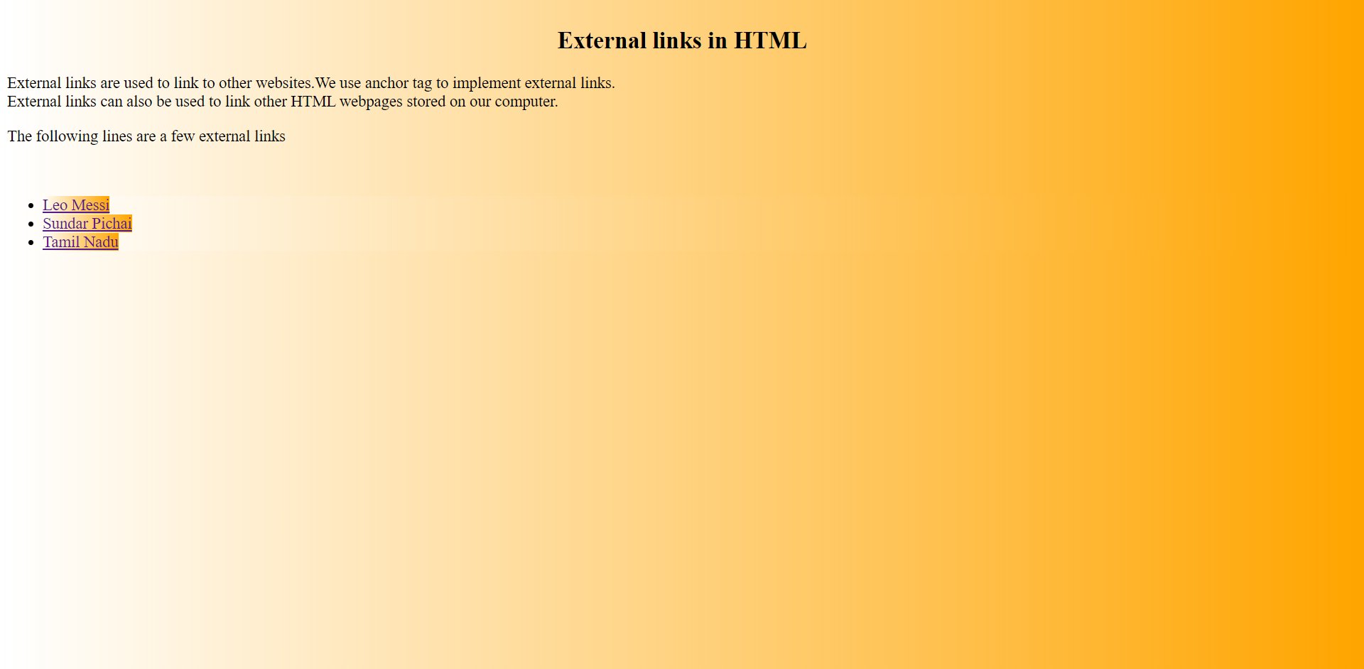

**9. Tables**

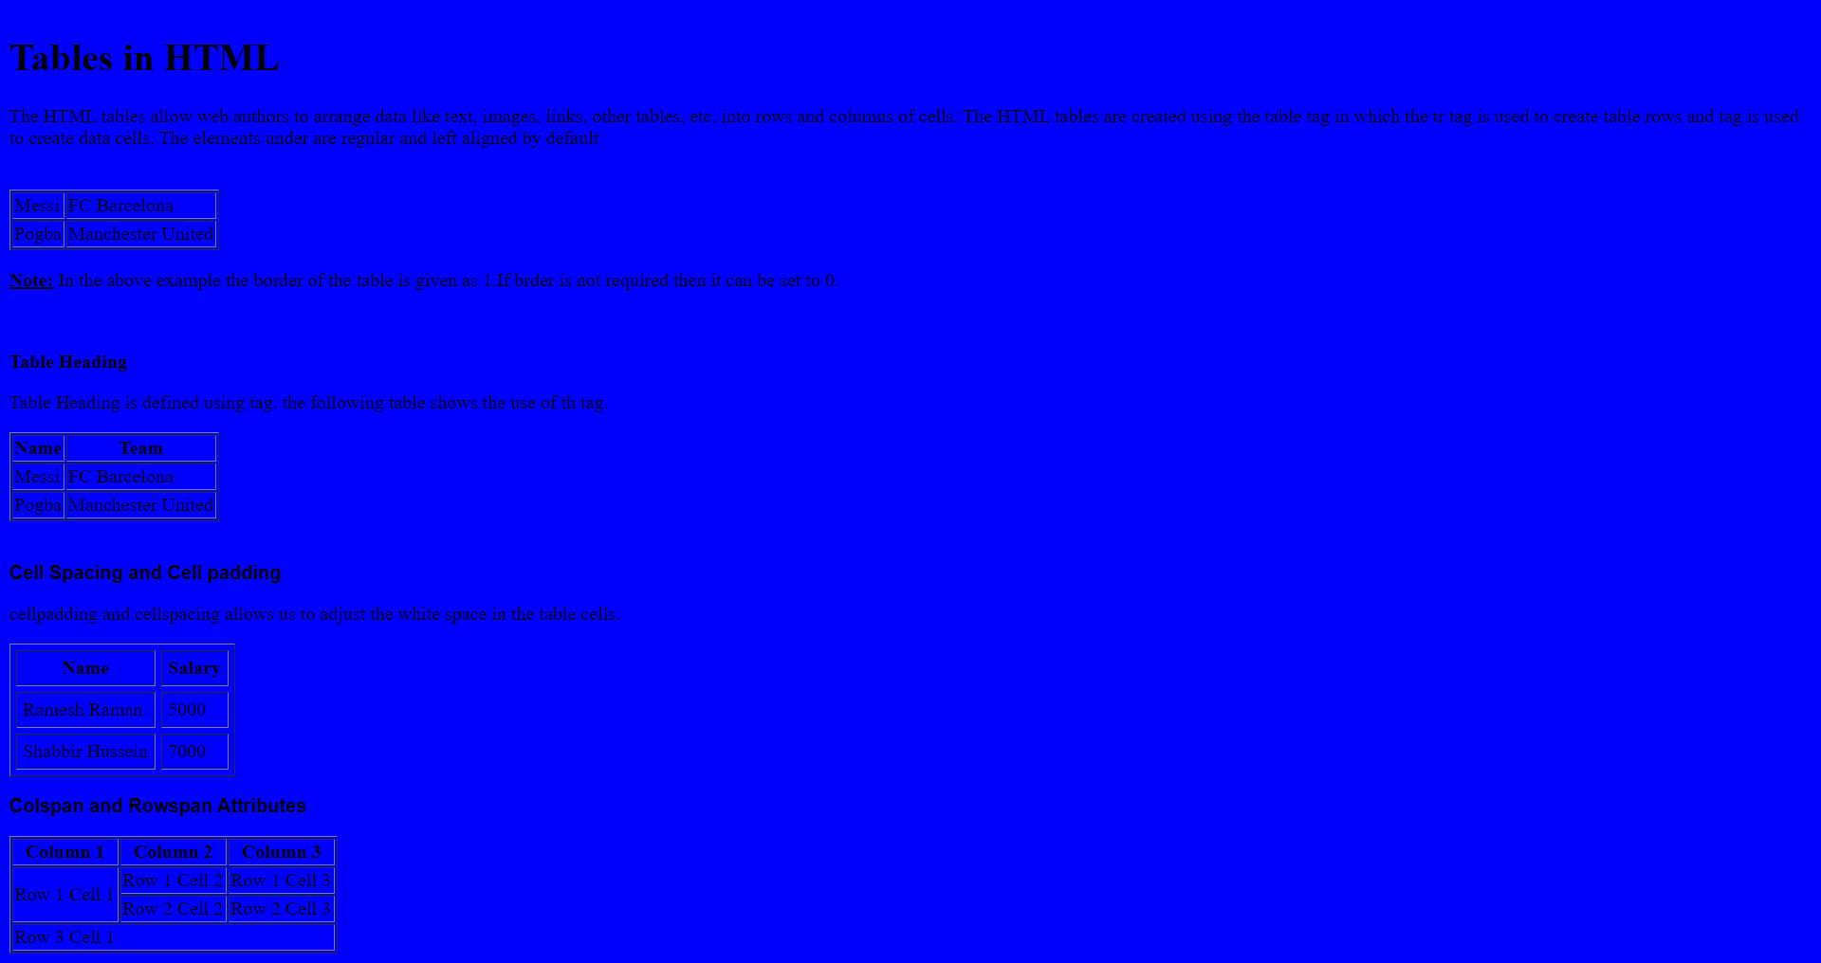

**10. Image and Image map:**

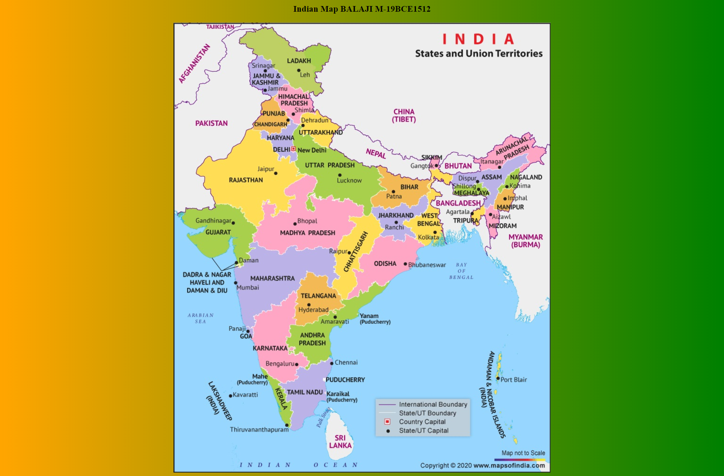

**11. iframe:**

**11.1 iframe example 1**

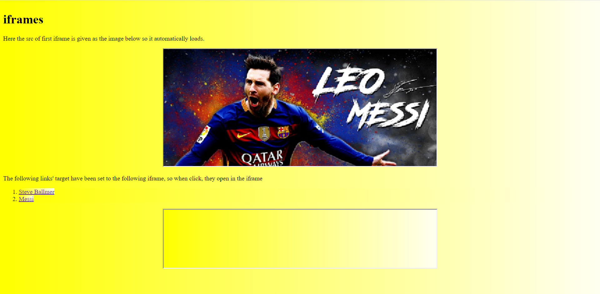

**11.2 iframe example 2(video streamer)**

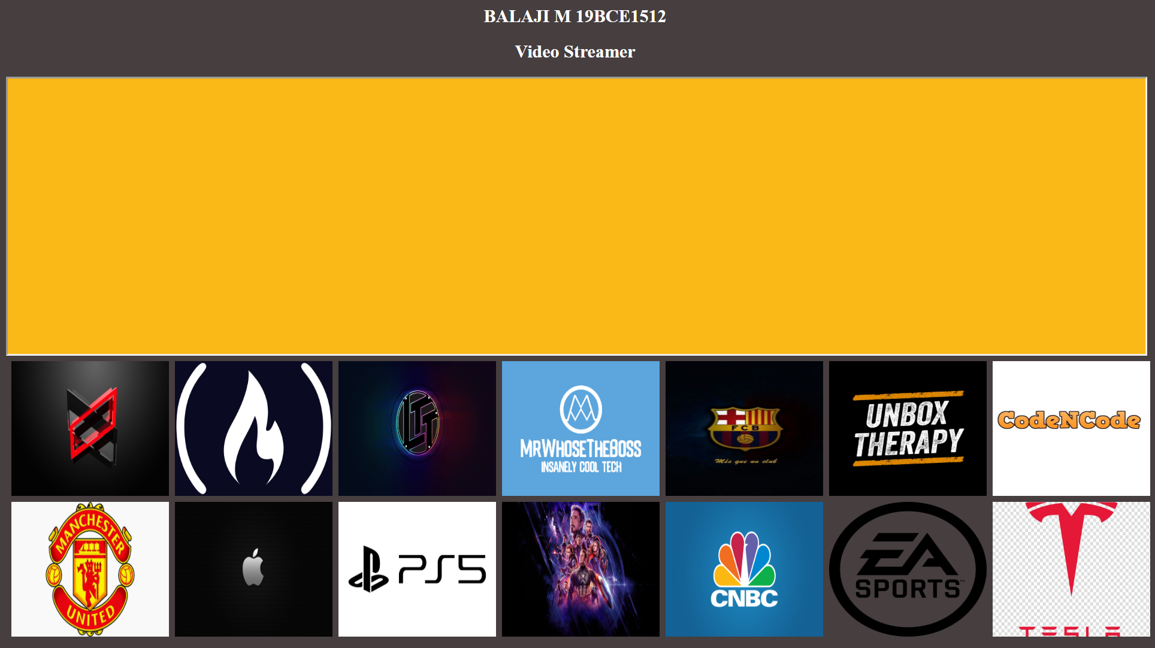

**CODES FOR ALL THE WEB PAGES:**

**1.Login-page:**

**Code(for login page):**

<!DOCTYPE html>

<html>

<head>

<title>Login_Page</title>

<style>

body{

background-image:url('html2.jpg');

}

div>p{

font-size:large;

text-align:center;

}

iframe{

margin-left:auto ;

margin-right:auto;

}

</style>

</head>

<body>

<p align="center"><iframe align="middle"allowtransparency="true" src="login.html" width="500px" height="1000"></iframe></p>

<div><p><mark>Developed by BALAJI M 19BCE1512<mark></p>

</body>

</html>

**Code (for login.html which is used as src for the iframe in login page):**

<!DOCTYPE html>

<html>

<head>

<title>HTML tutorial log in</title>

<style>

.center {

display: block;

margin-left: auto;

margin-right: auto;

width: 100%;

}

</style>

</head>

<body>

</br></br>

<img class="center" width="100%" height="30%" src="html_logo.jpg"/>

</br></br></br>

<form action="content-page.html" target="_blank">

<p style="text-align:center;font-size:50px"><label style="color:white">Username:<input type="text" placeholder="username" size='25' name="usrname" required/></label></p>

</br>

<p style="text-align:center;font-size:50px"><label style="color:white">Password:<input type="password" placeholder="password" size='25' name="pswd" required/></label></p>

<center><p style="color:green"><label><input type="submit" style="background-color:green;width:20em;height:3em"/ ></label></p></center>

</br></br><i>Note: Existing users can enter their existing username and password. New users can also login through this page by entering their new username and password.</i>

</form>

</body>

</html>

**2.Contents page:**

Code:

<!DOCTYPE html>

<html>

<head>

<title>Contents Page</title>

<h1 style="text-align:center">Contents Page</h1>

<h2 style="text-align:center"><mark>Developed by BALAJI M 19BCE1512</mark></h2>

<style>

*{

background-image:linear-gradient(to right,purple,blue);

color:white;

}

a:hover{

font-size:25px;

}

ol{

list-style-position:inside;

font-size:large;

left-margin=70px;

}

h2 mark{

font-size:large;

color:yellow;

}

</style>

</head>

<body>

<center>

<iframe src="img1.html" width="40%" scrolling="no" height="300px" style="background:black"></iframe>

</center>

<iframe src="img2.html" width="25%" height="500px" align="left" scrolling="no" style="background:black"></iframe>

<div style="color:white">

<ol >

<li><a href="IWP.html##one" target="_blank">Basic tags and formatting tags</a></li></br>

<li><a href="IWP.html##Forms" target="_blank">Forms in HTML</li></br>

<li><a href="IWP.html##list" target="_blank">Lists</li></br>

<li><a href="IWP.html##Links" target="_blank">Links</li></br>

<li><a href="IWP.html##Tables" target="_blank">Tables</li></br>

<li><a href="IWP.html##image" target="_blank">Image and image map</li></br>

<li><a href="IWP.html##iframe" target="_blank">iframe</li>

</ol>

</div>

</body>

</html>

**3. Tutorial and explanation page:**

Code:

<!DOCTYPE html>

<html>

<header style="background-color:#463E3F">

<h1 style="text-align:center;background-color:#463E3F;color:white">HTML Tutorial</h1>

<h3 style="text-align:center;background-color:#463E3F;color:white">Developed by BALAJI M 19BCE1512</h3>

</header>

<style>

#intro{

font-size:large;

color:#008080;

}

big~code{

text-decoration:underline;

}

p#exp { color:red;font-size:large;font-family:Arial;}

#listdiv{

font-size:medium;

}

</style>

<link rel="stylesheet" href="home.css"/>

</head>

<body>

<main>

<nav style="text-align:center;background-color:#463E3F;color:orange">

HTML-Hyper text markup language|

CSS-Cascading Style Sheets|

JavaScript|

Web development

</nav>

<hr>

</br>

<img class="center" src="HTML5.png"/>

<div><p id="intro" style="">HTML stands for Hyper Text Markup Language.HTML is the standard markup language for creating Web pages.HTML is used for creating the static content of the webpage. HTML is often combined with CSS(Cascading Style Sheets),PHP and JavaScript to develop and manage websites.

HTML was discovered by Tim Berners-Lee a contractor at CERN,who proposed and prototyped ENQUIRE, a system for CERN researchers to use and share documents. In 1989, Berners-Lee wrote a memo proposing an Internet-based hypertext system.This was the begining of HTML.

</br> HTML uses a wide range of tags for it's implementation. </p>

<p style="font-size:large;color:#228B22">In this tutorial we will be seeing the all the tags and in HTML</p>

</div>

<h2 style="text-align:center;text-shadow:5px 2px 4px grey"><a name="#Basic_tags">Basic tags and formatting tags in HTML</a></h2>

<p style="font-family:Florence,cursive">Few basic and formatting tags in HTML are:</br>

<ul>

<li><b><u><code><big><big>!DOCTYPE</big></big></code></u></b>:A doctype or document type declaration is an instruction which tells the web browser about the markup language in which the current page is written. The Doctype is not an element or tag, it lets the browser know about the version of or standard of HTML or any other markup language that is being used in the document.

A DOCTYPE declaration appears at the top of a web page before all other elements. According to the HTML specification or standards, every HTML document requires a document type declaration to ensure that the pages are displayed in the way they are intended to be displayed.</br>

For HTML documents, we give the DOCTYPE as html</li>

</br>

<li><b><u><big><big><code>html tag: </code></big></big></u></b>This tag is used in all HTML programs. It indicates the begining of the html program. This is the tag that marks that the document should be interpreted as a HTML document.</li>

</br>

<li><b><u><big><big><code>head tag: </code></big></big></u></b>The head of an HTML document is the part that is not displayed in the web browser when the page is loaded. It contains information such as the page <code>title</code>, links to CSS (if you choose to style your HTML content with CSS), links to custom favicons, and other metadata (data about the HTML, such as the author, and important keywords that describe the document.)</li>

<li><b><u><big><big><code>title tag: </code></big></big></u></b>This contains the title of the webpage, it is the name that appears on the browser tab when we open the HTML document</li>

</br>

<li><b><u><big><big><code>body tag: </code></big></big></u></b>This tag is used for defining the document's body.</li>

</br>

<li><b><u><big><big><code>hr tag: </code></big></big></u></b>Used for drawing a horizontal line or a horizontal rule.</li>

<li><b><u><big><big><code>br tag: </code></big></big></u></b>It is known as break tag.It is used for inserting a line break.</li>

<li><b><u><big><big><code>hr tag: </code></big></big></u></b>Used for horizontal rule.</li>

<li><strong><big><big><code><u>heading tag: </u></code></big></big></strong>HTML has 6 heading tags(h1 to h6) which define HTML headings.

The size of the text decreases from h1 to h6.The following is an example of heading tags from h1 to h6.</br>

<output><img src="Heading_output.png" style="display: block;margin-left: auto;margin-right: auto;height:170px"/></output>

</li>

</ul>

</br>

<span class="expl"><p id="exp">For more explanation of Basic_tags</p></span>

<a href="BT.html" target="_blank"><big>click here</big></a>

</br>

<span class="expl"><p id="exp">For more explanation of Formatting_tags</p></span>

<big><a href="formatting tags.html" target="_blank">click here</a></big>

<h2 style="text-align:center;text-shadow:5px 2px 4px grey;color:#228B22"><a name="#Forms">Forms in HTML</a></h2>

<p>Form tag is a new inclusion in HTML 5. It is a great method to create online forms. There are many different kinds of inputs like radiobutton, checkboxes etc. which are supported by the form tag.

Along with forms often a label is used to indicate the name of the field for the convinience of the user. The information entered through the form is then accessed and used using JavaScript and PHP at the back end.

</p>

<p>The following are some of the input types supported by HTML:</p>

<ol>

<li><b>Text</b>: This allows us to get a text input often used for text fields such as username and password.</br>

A text box can be implemented by assigning the type attribute to "text" inside the input tag.</br>Syntax is:<code><big>&ltinput type="text"/&gt</big></code>

</li>

</br>

<li><b>Radio button</b>: Radio button can be used in scenarios where the user has the choice of selecting only one of the options. It is often used in 'yes' or 'no' cases, gender selection etc.</br>

A radio button can be rendered by assigning the type attribute of the input tag to "radio".</br>Syntax is: <code><big>&ltinput type="radio"/&gt</big></code>

</li>

</br>

<li><b>Checkbox</b>: Checkboxes are used in scenarios where the user can/has to select two or more of the given choices.Commonly used in check lists.</br>

It can be rendered by assigning the type attribute of input tag to "checkbox".</br> Syntax is: <code><big>&ltinput type="checkbox"/&gt</big></code></li>

</br>

<li><b>file</b>: Files are generaaly used in forms where the user has to upload a file. Mostly used in sites where verification of one's photograph is required or one's resume is required.</br>

A file upload option can be included by assigning the type attribute of input tag to "file".</br>

Syntax is: <code><big> &ltinput type="file"/&gt</big></code></li>

</br>

<li><b>email</b>: Used for accepting emails via forms. It checks whether the @ symbol and the period '.' is present in the user entered string.

</br>Syntax is: <code><big>&ltinput type="email"/&gt</code></big></li>

</br>

<li><b>submit and reset</b>: These buttons are generally included in all form. The submit button is for submitting the form and recording our responses. The reset button is for clearing all our responses to start from scratch</br>

Syntax is:<code><big>&ltinput type="submit|reset"/&gt</big></code></li>

</ol>

<h4><u>Select tag:</u></h4>It is used for creating a drop down list containing many options.The option tag is used for specifying the options.</br>

Syntax is:<code><big>&ltselect&gt &ltoption&gt ...&lt/option&gt &lt/select&gt</big></code>

</br>

<span><p><a href="Form.html" target="_blank">Click here to see a form in HTML</a></p></span>

<h2 style="text-align:center;text-shadow:5px 2px 4px grey;color:1E90FF"><a name="#list">Lists</a></h2>

<div id="listdiv">

<p>Lists are a good method to display list of values or a set of values. Lists in HTML are of three types:

<ol>

<li><a href="list.html" target="_blank">Ordered</a></li>

<li><a href="Unordered-list.html" target="_blank">Unordered</a></li>

<li><a href="Description-list.html" target="_blank">Description</a></li>

</ol>

<p>

</div>

<div>

<h2 style="text-align:center;text-shadow:5px 2px 4px grey;color:#191970"><a name="#Links">Links in HTML</a></h2>

<p>A link is specified using HTML tag &lta&gt. This tag is called anchor tag and anything between the opening &lta&gt tag and the closing &lt/a&gt tag becomes part of the link and a user can click that part to reach to the linked document. Following is the simple syntax to use &lta&gt tag.

</br></br>&lta href="..." target="_blank|self|iframe"&gt...&lt/a&gt.</br>

<p>The &lta&gt tag has two main attributes which are href and target. href is used to specify the source URL or the path of the webpage to which it should navigate to on clicking upon the link.

The target attribute determines the window or the tab in which the link opens. If we set the target as _self then the link gets loaded in the same tab. If we give the target as _blank, the link gets loaded in a separate tab.If we give the target as iframe,

then it opens in the corresponding iframe.

<p>There are two types of link in HTML, click on each of those to explore them...</p>

<ol>

<li><a href="Internl-links.html" target="_blank">Internal links</a></li>

<li><a href="Externl-links.html" target="_blank">External links</li>

</ol>

</div>

<div style="font-family:Arial">

<h2 style="text-align:center;text-shadow:5px 2px 4px grey;color:green"><a name="#Tables">Tables in HTML</a></h2>

<p >A table is an arrangement of data in rows and columns, or possibly in a more complex structure. Tables are widely used in communication, research, and data analysis.

Tables are useful for various tasks such as presenting text information and numerical data.

Tables can be used to compare two or more items in tabular form layout.

Tables are used to create databases.

</br>

Tables are created using &lttable&gt tag. The rows are defined using &lttr&gt tag.The table headers are defined using &ltth&gt tag.The table data is defined using &lttd&gt tag.</br>

Cell spacing and cell padding can also be implemented. We can use colspan and rowspan to merge rows and columns.

</br></br>Syntax is:</br>

<code><big>&lttable&gt&lttr&gt &ltth&gt...&lt/th&gt &lttd&gt ... &lt/td&gt &lt/tr&gt &lt/table&gt </big></code>

</p>

</br>

<p>To explore more about tables and their implementation,<a href="Tables.html" target="_blank"> click here</a></p>

</div>

<div style="font-family:sans-serif">

<h2 style="text-align:center;text-shadow:5px 2px 4px grey;color:orange"><a name="#image">Image and image map</a></h2>

<p> HTML allows us to add images in webpages using &ltimg&gt tag. We can set different sections of the image to navigate to different webpages by using imagemap.

</br>The img tag must contain a src attribute which is mandatory. We specify the source of the webpage to be navigated inside the src attribute.

</br>The following is the Syntax for img tag in HTML:</br>

<code><big>&ltimg src=".."/&gt</big></code>

</br>Image map is also called client side mapping. We link sections of an image to create an image map.</br>

In order to use image map, we use the attribut usemap which is assigned to the corresponding map Id and another attribute ismap for mapping.Apart from this, we use a map tag

which contains the details of the areas of the image to be mapped for which area tag is used. Inside the area tag, we specify the type of shape and coordiantes

of the image to be mapped.</br></br>

The following is the syntax to implement image map:</br>

<code><big>

&ltimg src="..." usemap="#one" ismap/&gt</br>

&ltmap name="#one"&gt</br>

&ltarea shape="poly|circle|rectangle" coords="..." href="..."/&gt</br>

&lt/map&gt</big>

</code></br></br>To explore more click below</br>

<a href="Indian_map.html" target="_blank"> India-Map </a>

</p>

</div>

<div style="font-family:Arial">

<h2 style="text-align:center;text-shadow:5px 2px 4px grey;"><a name="#iframe">iframes in HTML</a></h2>

<p>

An iframe or inline frame is used to display external objects including other web pages within a web page. An iframe pretty much acts like a mini web browser within a web browser. Also, the content inside an iframe exists entirely independent from the surrounding elements.</br>

</br>The basic syntax for adding an iframe to a web page can be given with:

</br><code><big>

&ltiframe src="URL"&gt&lt/iframe&gt</big></code></br>

</br>The URL specified in the src attribute points to the location of an external object or a web page. We can also set the target of &lta&gt tag to iframe so that it opens the link in the particular iframe.

</br>

Here are two examples of iframes:<big> <a href="iframe.html" target="_blank">example1</a> <a href="Video_streamer.html" target="_blank">Video Streamer</a></big>

</main>

</br>

<footer>

<p style="text-align:center">

These are the tags of HTML hope u liked the tutorial!!

</p>

</footer>

</body>

</html>

**Code for stylesheet of tutorial and explanation page:**

body{

background-image:linear-gradient(to right,#00FFFF,white);

}

img{

width:200px;

height:200px;

}

.center{

display: block;

margin-left: auto;

margin-right: auto;

}

**4.Basic tags:**

Code:

<!DOCTYPE html>

<html>

<head>

<title>Basic tags in HTML</title>

<h2 style="text-align:center">Basic tags in HTML</h2>

<style>

*{

background-color:#A9A9A9;

}

p:first-letter{

font-size:large;

}

h4+p{

color:red;

}

</style>

</head>

<body>

<p>The following are basic tags in HTML</p>

</br>

<p style="color:red">html tag: It defines an HTML document</p>

</br>

<p style="color:blue">head Tag: Contains metadata/information for the document</p>

</br>

<p style="color:green">title tag: Defines a title for the document</p>

</br>

<p style="color:red">body tag: Defines the document's body</p>

</br>

<p style="color:green">Heading tags(h1 to h6): Defines HTML headings</p>

</br>

<p style="color:blue">p tag: Defines a paragraph</p>

</br>

<p style="color:red">br tag: Inserts a line break</p>

</br>

<p style="color:green">hr tag: Defines a thematic change in the content</p>

</br>

<p style="color:red">&lt!--...--&gt tag: Defines a comment</p>

</body>

</html>

**5.Formatting tags:**

<!DOCTYPE html>

<html>

<head>

<h2 style="text-align:center">Useage of formatting tags</h2>

<style>

body{

font-size:large;

background-image:linear-gradient(to right,#C0C0C0,white);

}

p[lang|="en"]{color:red;}

h4:first-line{font-weight:bolder;}

p.one{

color:green;

}

</style>

</head>

<body>

Basic formatting tags are:

<h4>Heading tag: It is used for headings varies from h1 to h5</h4>

<i>Italics: Used for displaying text in Italics denoted by i.</i>

</br>

</br>

<em>Emphasis tag: Used for emphasizing particlular text.</em>

</br>

</br>

<b><cite>Cite tag: Defines the title of a work.</cite></b>

</br></br>

<b>Bold tag: Displays text in bold.</b>

<p lang="en">Font tag is used for changing font color,size and text.The following lines illustrate the use of font tag in changing the font style. </p>

</br>

<font face = "Times New Roman" size = "6">I like Web programming</font><br />

<font face = "Verdana" size = "6">I like web programming</font><br />

<font face = "Comic sans MS" size =" 6">I like web programming</font><br />

<font face = "WildWest" size = "6">I like web programming</font><br />

<font face = "Bedrock" size = "6">I like web programming</font><br />

<p class="one">The following lines show the use of font tag to change the font size.</p>

</br>

<font size = "1">I like Web programming</font><br />

<font size = "2">I like Web programming</font><br />

<font size = "3">I like Web programming</font><br />

<font size = "4">I like Web programming</font><br />

<font size = "5">I like Web programming</font><br />

<font size = "6">I like Web programming</font><br />

<font size = "7">I like Web programming</font>

</br>

<p>The following lines of code depicts the use of font tag in changing the text color.</p>

<font color = "#009900">I like web programming</font><br />

<font color = "green">I like web programming</font>

</br>

</br>

<tt>Typewriter tag: Used for typewriter like font.</tt>

</br>

</br>

<strong>Strong tag:Defines important text in bold letters</strong>

<p>The above tags discussed were some of the basic formatting tags.</p>

</body>

</html>

**6.Forms in HTML:**

Code:

<!DOCTYPE html>

<html>

<head>

<title>Event registration</title>

<h2 style="background-color:blue;color:white;text-align:center">Event Registration</br>Balaji M 19BCE1512</h2>

<style>

body{

background-color:#FFDAB9

}

</style>

</head>

<body>

<form>

<div id="yesorno">

<label for="yes_or_no"><h3>Are u attending?*</h3></label>

<p><input type="radio" name="reg" value="registration_confirmation" checked>Yes</input>

</br></br>

<input type="radio" name="reg" value="registration_non_confirmation">No</input>

</div>

<label><h3>NAME*:</h3><input type="text" name="firstname" placeholder="firstname" required/></label>

<input type="text" name="lastname" placeholder="lastname" />

</br>

<small><pre>firstname lastname</pre></small>

<label><h3 style="color:green">E-Mail*:</h3><input type="email" placeholder="email@email.org" required/></label>

</br></br>

<label><h3>SMS-Number</h3><input type="text" size="3" placeholder="+91" /> <input type="text"/ placeholder="897634521"></label>

<label><h3><b>Phone Number*</b></h3><input type="text" size="3" placeholder="039" required > </input><input type="text" placeholder="222-222-222" required/></label>

</br></br>

<h3>How many guests?*</h3>

<select name="Noofguests">

<option>Please Choose</option>

<option>1</option>

<option>2</option>

<option>3</option>

<option>4</option>

<option>5</option>

</select>

</br></br>

<label><h3>Upload your photograph here:*</h3><input type="file" name="photoupload" required /></label>

</br></br>

<p><u>NOTE:</u>The fields marked * are mandatory.</p>

<input style="color:white;position:absolute;background-color:green;border:3px solid green;position:relative;left:50%" name="regbutton" type="submit" value="Register"/>

</form>

</body>

</html>

**7.Lists:**

**7.1 Unordered lists:**

Code:

<!DOCTYPE html>

<html>

<head>

<h1 id="one" style="text-align:center">Unordered Lists in HTML</h1>

<title>Unordered_list_in_html</title>

<style>

body{

background-image:linear-gradient(to left,red,yellow);

}

#one{

border-style:outset;

border-color:black;

}

</style>

</head>

<p>Unordered lists are not ordered and are bulleted.</p>

<p>An unordered list starts with &ltul&gt tag and ends with &ltul/&gt. The list elements are entered using the &ltli&gt tag.</br>

The following is a syntax\structure of an unordered list in HTML</br>

&ltul&gt</br>&ltli&gt...&lt/li&gt</br>&lt/ul&gt.

</p>

<p>The following lines depict an unordered list in HTML.Unordered lists are marked with a bullet.</p>

<ul>

<li>Messi</li>

<li>Zlatan</li>

<li>Pogba</li>

<li>Aubameyang</li>

</ul>

<p>There are three types of bullets:disc,circle and square</p>

<p>The bullets can be specified using the type attribute of ul tag as follows:</br>

<code>&ltul type="circle|square|disc"&gt</code>

<ul>

<li>disc</li>

<li>circle</li>

<li>square</li>

</ul>

<p>Nesting of unordered lists is also possible. The following example illustrates the nesting of un ordered lists</p>

<ul type="circle">

<li>

Google

<ul type="square">

<li>Larry Page and Sergey Brin</li>

<li>Sundar Pichai</li>

</ul>

</li>

<li>Microsoft

<ul type="disc">

<li> Bill Gates</li>

<li>Steve Ballmer</li>

<li>Sathya Nadella</li>

</ul>

</li>

<li>Apple

<ul type="circle">

<li>Steve Jobs</li>

<li>Steve Wozniak</li>

<li>Tim Cook</li>

</ul>

</li>

</ul>

<p>The above were a few basic examples of un-ordered lists in html</p>

</body>

</html>

**7.2. Ordered list**

Code:

<!DOCTYPE html>

<html>

<head>

<h1 id="one" style="text-align:center">Ordered Lists in HTML</h1>

<title>Ordered_list_in_html</title>

<style>

body{

background-image:linear-gradient(to right,red,yellow);

}

#one{

border-style:outset;

border-color:black;

}

</style>

</head>

<body>

<p>Ordered lists are ordered based on numbers or roman numerals</p>

<p>An ordered list starts with &ltol&gt tag and ends with &ltol/&gt. The list elements are entered using the &ltli&gt tag.</br>

The following is a syntax\structure of an ordered list in HTML</br>

&ltol&gt</br>&ltli&gt...&lt/li&gt</br>&lt/ol&gt.

</p>

<p>The following lines depict an ordered list in HTML.Ordered lists are marked with an indexing or numbering.</p>

<ol>

<li>Messi</li>

<li>Zlatan</li>

<li>Pogba</li>

<li>Aubameyang</li>

</ol>

<p>There are different types of ordering like</p>

<ol>

<li>Type '1', the list items will be numbered with numbers.</li>

<li>Type 'A', the list items will be ordered with uppercase letters.</li>

<li>Type 'a', the list items will be ordered with lowercase letters.</li>

<li>Type 'I', the list items will be ordered with uppercase roman numbers.</li>

<li>Type 'i', the list items will be ordered with lowercase roman numbers.</li>

</ol>

<p>Nesting of ordered lists is also possible. The following example illustrates the nesting of un ordered lists</p>

<ol type="1">

<li>

Google

<ol type="A">

<li>Larry Page and Sergey Brin</li>

<li>Sundar Pichai</li>

</ol>

</li>

<li>Microsoft

<ol type="a">

<li> Bill Gates and Paul Allen</li>

<li>Steve Ballmer</li>

<li>Sathya Nadella</li>

</ol>

</li>

<li>Apple

<ol type="I">

<li>Steve Jobs</li>

<li>Steve Wozniak</li>

<li>Tim Cook</li>

</ol>

</li>

<li>PayPal

<ol type="i">

<li>Elon Musk</li>

<li>Bill Harris</li>

<li>Daniel Schulman</li>

</ol>

</li>

</ol>

<p>The above were a few basic examples of ordered lists in html</p>

</body>

</html>

**7.3 Definition/description list:**

Code:

<!DOCTYPE html>

<html>

<head>

<title>Definition list</title>

<h2 style="text-align:center">Definition list</h2>

<style>

p,dl{

font-size:large;}

</style>

</head>

<body>

<p style="background-color:red">HTML Description List or Definition List displays elements in definition form like in dictionary.</br> The dl dt and dd tags are used to define description list.</p>

</br>

<p>The 3 HTML description list tags are given below:</p>

<dl style="color:blue">

<dt>HTML</dt>

<dd>is a markup language</dd>

<dt>Java</dt>

<dd>is a programming language and platform</dd>

<dt>JavaScript</dt>

<dd>is a scripting language</dd>

<dt>SQL</dt>

<dd>is a query language</dd>

</dl>

</body>

</html>

**8. Links**

**8.1 Internal links**

Code:

<!DOCTYPE html>

<html>

<head>

<title>Internal links in HTML</title>

<h2 style="text-align:center">Internal Links</h2>

<style>

*{

background-image:linear-gradient(to right,white,blue);

}

</style>

</head>

<body>

<p><h3>Internal links are used to navigate to different sections of the same web page</h3></p>

<p>We use anchor tag for implementing links in HTML</p>

<p>The following illustrates the working of internal links. There are 4 internal links placed at the bottom to navigate to diffterent section.</p>

<h3 style="background-color:blue">STEVE BALLMER</h3>

<img src="Steve-Balmer.jpg"/>

<ol>

<li><a name="one">Early life and education</a>

<p>Ballmer was born in Detroit; he is the son of Beatrice Dworkin and Frederic Henry Ballmer (Fritz Hans Ballmer), a manager at the Ford Motor Company.</br> His father was a Swiss immigrant who predicted that his son, at eight years old, would attend Harvard. His mother was Belarusian Jewish. Through his mother, Ballmer is a second cousin of actress and comedian Gilda Radner. Ballmer grew up in the affluent community of Farmington Hills, Michigan.</br> Ballmer also lived in Brussels from 1964 to 1967, where he attended the International School of Brussels.</p>

<p>In 1973, he attended college prep and engineering classes at Lawrence Technological University.</br> He graduated as valedictorian from Detroit Country Day School, a private college preparatory school in Beverly Hills, Michigan, with a score of 800 on the mathematical section of the SAT and was a National Merit Scholar.He now sits on the school's board of directors.</br> In 1977, he graduated magna cum laude from Harvard University with a Bachelor of Arts in applied mathematics and economics.</p>

</li>

<li><a name="two">History with Microsoft</a>

<p>On January 13, 2000, Ballmer was officially named the chief executive officer.</br> As CEO, Ballmer handled company finances and daily operations, but Gates remained chairman of the board and still retained control of the "technological vision" as chief software architect.</br> Gates relinquished day-to-day activities when he stepped down as chief software architect in 2006, while staying on as chairman, and that gave Ballmer the autonomy needed to make major management changes at Microsoft.</p>

</li>

<li><a name="three">Public image</a>

<p>

Although as a child he was so shy that he would hyperventilate before Hebrew school,Ballmer is known for his energetic and exuberant personality, which is meant to motivate employees and partners, shouting so much that he needed surgery on his vocal cords.

</br>Ballmer's flamboyant stage appearances at Microsoft events are widely circulated on the Internet as viral videos.</br>One of his earliest known viral videos was his promotion of Windows 1.0 for a Crazy Eddie commercial in 1985, where he energetically shouts "How much do YOU think this advanced operating environment is worth? WAIT just one minute before you answer".Ballmer and Brian Valentine repeated this in a spoof promotion of Windows XP later on.</br>

</br>A widely circulated video was his entrance on stage at Microsoft's 25th anniversary event in September 2000, where he shouted and jumped across the stage, and saying "I love this company". It has been nicknamed 'monkey boy dance'. Another well-known viral video was one captured at a Windows 2000 developers' conference, featuring a perspiring Ballmer chanting the word "developers".

<li><a name="four">Retirement</a>

<p>After saying in 2008 that he intended to remain CEO for another decade, Ballmer announced his retirement in 2013, after losing billions of dollars in acquisitions and on the Surface tablet. Microsoft's stock price rebounded on the news.</br>

Ballmer says that he regretted the lack of focus on Windows Mobile in the early 2000s, leaving Microsoft a distant third in the current smartphone market. Moreover, he attributed the success of the expensively-priced iPhones to carrier subsidies.</br> He went on to say,

People like to point to this quote where I said iPhones will never sell, because the price at $600 or $700 was too high. And there was a business model innovation by Apple to get it essentially built into the monthly cellphone bill.

</p>

</li>

</ol>

</br>

<p>The following are famous CEOs of Microsoft</p>

<ul>

<li>Bill Gates</br></li>

<li>Steve Ballmer</br></li>

<li>Sathya Nadella</br></li>

<li>Paul Allen</li>

</br></br></br>

<a href="#one">Go to section one</a>

</br>

<a href="#two">Got to section two</a>

</br>

<a href="#three">Go to section three</a>

</br>

<a href="#four">Go to section four</a>

</br>

</body>

</html>

**8.2 External links:**

Code:

<!DOCTYPE html>

<html>

<head>

<title>External links in HTML</title>

<style>

body{

font-size:large;

}

*{

background-image:linear-gradient(to right ,white,orange);

}

</style>

<h2 style="text-align:center">External links in HTML</h2>

</head>

<body>

<p>External links are used to link to other websites.We use anchor tag to implement external links.</br>External links can also be used to link other HTML webpages stored on our computer.</p>

<p>The following lines are a few external links</p>

</br>

<ul>

<li><a href="https://en.wikipedia.org/wiki/Lionel_Messi">Leo Messi</a></li>

<li><a href="https://en.wikipedia.org/wiki/Sundar_Pichai">Sundar Pichai</a></li>

<li><a href="https://www.britannica.com/place/Tamil-Nadu">Tamil Nadu</a></li>

</ul>

</body>

</html>

**9. Tables:**

Code:

<!DOCTYPE html>

<html>

<head>

<title>Tables in html</title>

<h1>Tables in HTML</h1>

<style>

body{

background-color:blue;

}

</style>

</head>

<body>

<p>The HTML tables allow web authors to arrange data like text, images, links, other tables, etc. into rows and columns of cells.

The HTML tables are created using the table tag in which the tr tag is used to create table rows and <td> tag is used to create data cells. The elements under <td> are regular and left aligned by default</p>

</br>

<table border = "1">

<tr>

<td> Messi</td>

<td>FC Barcelona</td>

</tr>

<tr>

<td>Pogba</td>

<td>Manchester United</td>

</tr>

</table>

<p><b><u>Note:</u></b> In the above example the border of the table is given as 1.If brder is not required then it can be set to 0.</p>

</br>

<p style="font-size:medium"><b>Table Heading</b></p>

<p>Table Heading is defined using <th> tag. the following table shows the use of th tag.</p>

<table border = "1">

<tr>

<th>Name</th>

<th>Team</th>

</tr>

<tr>

<td> Messi</td>

<td>FC Barcelona</td>

</tr>

<tr>

<td>Pogba</td>

<td>Manchester United</td>

</tr>

</table>

<br/>

<p style="font-family:Arial" ><b>Cell Spacing and Cell padding</b></p>

<p>cellpadding and cellspacing allows us to adjust the white space in the table cells.</p>

<table border = "1" cellpadding = "5" cellspacing = "5">

<tr>

<th>Name</th>

<th>Salary</th>

</tr>

<tr>

<td>Ramesh Raman</td>

<td>5000</td>

</tr>

<tr>

<td>Shabbir Hussein</td>

<td>7000</td>

</tr>

</table>

<p style="font-family:Arial" ><b>Colspan and Rowspan Attributes</b></p>

<table border = "1">

<tr>

<th>Column 1</th>

<th>Column 2</th>

<th>Column 3</th>

</tr>

<tr>

<td rowspan = "2">Row 1 Cell 1</td>

<td>Row 1 Cell 2</td>

<td>Row 1 Cell 3</td>

</tr>

<tr>

<td>Row 2 Cell 2</td>

<td>Row 2 Cell 3</td>

</tr>

<tr>

<td colspan = "3">Row 3 Cell 1</td>

</tr>

</table>

</body>

</html>

**10.Image and Image map:**

Code:

<!DOCTYPE=html>

<html>

<head>

<title>Indian Map</title>

<h3 style="text-align:center">Indian Map BALAJI M-19BCE1512</h3>

<style>

*{

background-image:linear-gradient(to right,orange,green);

}

</style>

</head>

<body>

<center><img class="image" src="india-political-map.jpg" align="middle" usemap="#map1" ismap /></center>

<map name="map1">

<area shape="poly" coords="244,859,273,857,276,844,308,836,297,824,308,805,326,802,321,763,337,716,311,718,305,726,290,725,282,738,266,731,259,745,265,760,241,761,224,767,240,806,250,804,248,861" title="Tamil Nadu" href="https://www.britannica.com/place/Tamil-Nadu" target="_blank" alt="Tamil Nadu" />

<area shape="poly" coords="182,730,202,746,229,762,220,768,230,772,240,804,248,801,244,859,182,730" title="Kerala" href="https://www.keralatourism.org/specialities/" target="_blank" alt="Kerala" />

<area shape="poly" coords="183,729,196,740,205,749,230,764,238,767,240,764,241,759,258,758,262,750,255,750,258,736,268,732,271,733,288,718,282,706,273,700,259,703,252,701,242,705,242,693,256,691,245,689,238,664,248,668,246,656,245,647,247,641,258,643,262,629,252,624,256,622,256,605,263,597,258,595,261,573,253,568,244,576,236,586,228,594,228,600,208,595,208,608,188,613,181,619,171,624,173,632,170,646,168,668,165,672,183,732" href="https://www.webindia123.com/karnataka/Index.htm" target="_blank" title="Karnataka" alt="Karnataka"/>

<area shape="poly" coords="153,644,160,646,162,649,170,648,168,660,164,670" href="https://www.treebo.com/blog/goa-is-famous-for/" target="_blank" title="Goa" alt="Goa"/>

<area shape="poly" coords="260,642,262,631,253,628,257,623,259,610,255,605,265,596,258,592,263,583,261,571,271,557,267,553,271,545,279,548,279,541,283,540,282,529,296,531,307,540,308,534,325,536,328,541,325,553,326,562,334,562,342,565,353,579,357,587,353,590,365,600,351,609,340,608,345,619,336,613,331,612,329,614,308,624,306,633,294,639,281,637,274,646,259,642" href="https://www.incredibleindia.org/content/incredibleindia/en/destinations/states/telangana.html" target="_blank" title="Telangana" alt="Telangana" />

<area shape="poly" coords="151,644,157,645,162,647,174,646,177,634,169,629,169,622,180,622,191,611,195,614,202,609,208,611,207,596,228,601,229,590,234,590,245,575,254,570,260,573,262,564,270,559,266,550,273,543,278,546,283,528,297,531,307,540,307,535,325,538,328,543,326,558,335,562,335,557,343,540,349,544,352,537,342,528,340,521,339,516,344,513,339,491,334,478,319,480,309,473,299,480,284,476,260,483,258,480,258,472,224,490,223,484,191,477,178,472,178,462,169,467,160,468,160,479,173,477,155,488,165,499,152,504,147,515,132,513,130,539,132,564,142,606,151,643" href="https://www.holidify.com/pages/culture-of-maharashtra-121.html" title="Maharashtra" alt="Maharashtra" target="_blank" />

<area shape="poly" coords="131,516,140,512,150,515,150,507,164,499,155,488,174,478,159,479,163,468,169,464,169,452,173,452,168,447,176,445,178,438,171,431,155,417,151,404,143,403,141,399,145,396,140,391,139,394,127,392,86,384,83,395,75,396,75,391,59,396,50,394,26,392,26,401,17,413,22,424,35,435,49,436,70,429,61,444,47,449,29,452,29,446,28,455,78,499,113,492,118,474,121,453,135,455,125,459,127,487,133,500,131,517" href="https://www.holidify.com/pages/gujarat-culture-139.html#:~:text=Food%20of%20Gujarat&text=Some%20of%20the%20famous%20Gujarati,associated%20with%20its%20local%20food." target="_blank" title="Gujarat" alt="Gujarat" />

<area shape="poly" coords="89,383,80,362,80,353,69,353,64,341,67,326,47,319,63,297,77,286,82,292,100,289,113,287,123,266,141,255,153,228,168,220,166,215,168,227,186,229,185,246,194,246,206,250,208,256,211,259,210,270,224,281,221,292,227,292,227,286,231,283,238,288,245,280,247,297,257,294,265,308,264,314,269,319,262,323,272,320,283,320,246,344,241,351,235,355,241,368,258,363,258,375,244,379,247,381,243,385,249,392,243,392,244,402,224,401,220,408,209,415,206,408,215,405,214,396,216,392,214,385,200,384,201,374,195,380,191,379,188,391,193,407,190,419,181,423,187,430,175,434,156,422,150,407,150,402,146,405,142,398,144,393,139,391,142,394,118,386,87,385" href="https://www.tourism-of-india.com/blog/top-reasons-to-visit-royal-state-rajasthan/" title="Rajasthan" alt="Rajasthan" target="_blank" />

<area shape="poly" coords="185,245,195,250,207,248,208,256,210,260,212,272,219,273,223,283,223,292,228,292,227,285,231,283,237,288,240,285,244,281,245,298,250,293,257,293,264,288,264,280,257,274,253,275,245,272,247,264,254,264,255,260,252,253,255,231,259,226,265,217,258,214,253,211,252,205,243,199,245,207,248,215,243,215,241,218,240,221,233,222,228,225,228,233,220,236,214,235,207,233,202,240,202,234,198,229,190,227,186,230,183,233,185,246" href="https://www.holidify.com/pages/haryana-culture-80.html" target="_blank" title="Haryana" alt="Haryana" />

<area shape="poly" coords="279,733,283,736,288,735,290,726,296,723,305,725,311,720,313,715,329,710,333,712,335,704,332,694,333,683,330,667,335,650,343,644,349,644,353,648,358,642,366,630,378,631,391,623,392,611,418,591,428,580,441,573,460,548,448,558,428,549,421,552,419,554,415,562,411,570,405,569,401,574,396,566,392,581,382,581,371,587,359,587,353,590,363,599,353,604,352,609,342,608,347,613,344,617,335,610,327,613,325,623,319,619,307,624,307,633,299,633,292,640,284,638,276,644,247,641,246,649,247,655,248,667,239,665,240,673,238,681,241,686,245,687,250,688,258,693,256,696,258,705,267,700,275,701,276,708,284,712,283,718,288,719,278,733" href="https://www.holidify.com/pages/andhra-pradesh-culture-190.html" title="Andhra Pradesh" alt="Andhra Pradesh" target="_blank" />

<area shape="poly" coords="168,226,169,222,166,217,178,204,185,195,183,189,185,186,186,181,184,173,193,168,205,162,208,158,211,155,219,149,221,155,214,158,215,163,222,170,226,182,229,189,232,185,239,189,240,195,244,203,247,215,242,215,238,220,240,225,231,225,229,225,229,232,224,236,218,233,212,234,203,241,202,232,198,229,188,229,185,228,168,227" href="https://trip101.com/article/punjab-is-famous-for-which-things#:~:text=Punjabi%20culture&text=Punjab%2C%20the%20land%20of%20five,love%20for%20food%20and%20drinks!" target="_blank" title="Punjab" alt="Punjab" />

<area shape="poly" coords="357,588,354,579,350,575,342,565,338,565,335,562,338,559,335,554,343,543,349,544,352,538,342,529,342,521,337,518,344,513,343,497,339,491,348,488,348,472,353,461,359,458,359,451,369,451,376,446,380,434,387,429,372,421,372,411,377,411,399,413,403,408,407,410,411,409,419,404,426,410,432,418,438,418,438,425,441,432,449,436,437,449,438,452,425,460,426,468,421,478,421,486,417,489,414,492,401,492,395,501,394,500,395,514,395,522,403,524,402,531,395,528,391,528,381,522,383,528,388,541,390,556,381,568,370,577,367,588,362,588,356,590" href="https://en.wikipedia.org/wiki/Chhattisgarh" target="Chhattisgarh" title="Chhattisgarh" alt="Chhattisgarh" />

<area shape="poly" coords="368,587,369,575,380,565,383,562,390,555,385,538,380,527,379,524,382,520,391,525,393,528,398,526,402,530,403,524,394,521,395,512,392,503,392,499,400,495,403,490,415,490,420,478,426,462,437,454,440,451,445,455,452,453,467,450,467,463,479,462,489,465,491,448,511,457,519,462,520,467,525,464,532,474,518,481,516,490,520,500,513,510,498,527,479,533,464,544,459,550,456,549,446,558,435,558,427,550,418,555,422,556,413,572,400,573,396,566,391,582,383,580,376,585,368,587" href="https://www.britannica.com/place/Odisha" target="_blank" title="Odisha" alt="Odisha" />

<area shape="poly" coords="532,474,524,464,519,462,510,458,514,455,508,445,502,442,502,435,494,435,485,428,485,425,492,417,501,421,507,416,516,409,523,406,536,396,540,384,536,364,537,363,542,361,542,356,538,345,550,330,546,327,541,316,542,310,553,312,559,309,570,318,581,320,592,323,589,334,582,343,571,338,568,335,569,337,559,331,553,327,557,335,547,341,547,351,554,355,566,359,570,366,555,368,553,378,544,382,552,391,562,395,563,406,562,416,567,419,567,425,571,426,573,440,565,459,553,465,546,452,543,455,547,462,540,470,531,474" href="https://www.britannica.com/place/West-Bengal" target="_blank" title="West Bengal" alt="West Bengal" />

<area shape="poly" coords="267,231,273,221,266,216,270,212,270,201,277,191,296,192,300,194,299,190,303,184,304,182,310,193,317,198,323,200,332,203,335,209,338,212,346,215,356,221,351,225,342,233,339,236,338,240,335,246,334,257,331,264,327,266,318,263,304,256,299,253,296,248,298,245,291,240,288,236,276,241,272,238,268,233,267,231" href="https://en.wikipedia.org/wiki/Uttarakhand" target="Uttarakhand" title="Uttarakhand" alt="Uttarakhand" />

<area shape="poly" coords="269,211,264,216,254,212,252,206,243,199,241,197,239,190,233,184,228,187,226,184,221,172,219,166,213,164,215,160,221,154,220,150,221,145,221,138,225,137,232,133,239,130,244,130,252,135,259,142,276,138,269,137,275,146,276,149,286,144,286,151,288,159,296,166,295,174,299,181,294,183,301,190,301,195,293,190,282,191,272,195,268,205,268,212,269,211" href="https://en.wikipedia.org/wiki/Culture_of_Himachal_Pradesh#:~:text=Himachal%20is%20well%20known%20for,art%20work%20of%20the%20people." target="_blank" title="Himachal Pradesh" alt="Himachal Pradesh" />

<area shape="poly" coords="206,156,195,151,189,151,188,141,180,142,171,135,163,132,161,129,162,117,161,102,159,89,160,86,165,83,170,78,173,76,177,70,182,71,189,70,193,77,201,79,210,79,214,97,224,105,232,113,236,120,245,130,233,132,227,138,219,150,208,157,206,156" href="https://www.britannica.com/place/Jammu-and-Kashmir" target="Jammu and Kashmir" title="Jammu and Kashmir" alt="Jammu and Kashmir" />

<area shape="poly" coords="177,70,168,65,169,57,156,53,153,45,139,43,141,31,152,22,174,19,168,13,180,14,193,10,200,13,208,9,245,40,245,45,257,52,259,59,288,49,304,47,307,43,322,49,327,48,330,54,332,78,317,93,315,102,303,105,305,114,301,119,314,128,313,137,317,146,313,150,302,157,295,145,287,148,286,145,275,149,269,139,257,140,245,131,229,108,212,96,205,78,197,79,191,75,188,69,176,70" href="https://www.treebo.com/blog/ladakh-is-famous-for/" target="_blank" title="Ladakh" alt="Ladakh" />

<area shape="poly" coords="543,310,543,299,549,288,557,284,563,285,564,294,562,301,565,303,565,305,562,310,558,309,552,312,543,310" href="https://en.wikipedia.org/wiki/Sikkim#:~:text=Sikkim%20is%20the%20least%20populous,and%20third%20highest%20on%20Earth." target="_blank" title="Sikkim" alt="Sikkim" />

<area shape="poly" coords="588,336,592,334,604,344,617,344,629,346,640,343,653,339,656,341,656,349,665,351,670,363,664,370,665,373,656,374,656,384,664,392,673,386,678,386,690,359,686,352,698,341,701,341,705,328,718,315,731,309,753,296,748,284,751,276,741,280,707,291,698,303,697,309,673,312,651,317,644,315,609,319,603,315,591,324,590,337,588,336" href="https://www.britannica.com/place/Assam" target="_blank" title="Assam" alt="Assam" />

<area shape="poly" coords="593,366,598,356,593,349,603,343,614,343,629,348,639,342,645,340,658,340,655,349,662,351,672,363,663,367,652,367,635,367,611,368,593,365" href="https://en.wikipedia.org/wiki/Meghalaya#:~:text=Meghalaya%20is%20also%20the%20home,forests%20in%20the%20Khasi%20hills." target="_blank" title="Meghalaya" alt="Meghalaya" />

<area shape="poly" coords="655,387,650,391,650,396,643,394,638,399,635,402,631,409,634,419,640,424,641,425,645,431,647,421,651,415,652,410,662,410,658,393,656,386" href="https://en.wikipedia.org/wiki/Tripura#:~:text=Tripura%20ranks%20second%20to%20Kerala,wood%20carvings%2C%20and%20bamboo%20products." target="_blank" title="Tripura" alt="Tripura" />

<area shape="poly" coords="662,410,662,431,670,454,672,457,674,454,680,458,684,452,688,451,683,436,690,425,690,410,689,400,685,396,679,396,679,385,663,393,662,394,662,410" href="https://en.wikipedia.org/wiki/Mizoram#:~:text=The%20name%20is%20derived%20from,namely%20Tripura%2C%20Assam%20and%20Manipur." target="_blank" title="Mizoram" alt="Mizoram" />

<area shape="poly" coords="424,390,418,378,420,371,429,366,442,356,453,355,436,346,436,341,440,338,433,332,445,327,436,315,431,306,439,302,448,308,453,309,453,315,468,323,480,321,484,327,492,327,510,331,516,328,524,333,540,330,547,333,544,330,547,335,538,346,541,358,535,365,538,366,529,366,520,374,515,389,503,390,500,395,489,384,481,383,476,391,459,395,456,391,449,396,441,391,436,388,421,392,424,390" href="https://en.wikipedia.org/wiki/Bihar" target="_blank" title="Bihar" alt="Bihar" />

<area shape="poly" coords="166,454,171,466,179,464,182,474,197,480,220,483,225,491,236,488,241,480,248,474,259,472,262,476,259,482,276,484,282,478,300,481,303,478,315,475,316,478,337,478,342,486,349,486,350,471,364,451,375,448,387,432,373,422,382,410,398,410,405,408,401,399,401,386,387,386,365,374,360,380,352,377,352,373,338,376,336,367,326,369,324,374,312,375,301,369,298,362,288,368,301,396,296,401,286,396,281,379,285,374,285,365,298,360,297,359,305,341,296,325,282,323,282,324,238,353,239,366,256,363,256,375,247,376,254,384,248,393,244,394,245,403,227,399,212,412,206,406,213,404,216,392,216,384,200,384,200,376,190,382,190,398,193,405,191,419,182,424,185,430,175,435,175,440,170,449,169,457,166,454" href="https://en.wikipedia.org/wiki/Madhya_Pradesh" target="_blank" title="Madhya Pradesh" alt="Madhya Pradesh" />

<area shape="poly" coords="710,401,698,399,687,397,681,395,681,376,689,360,695,363,700,352,710,354,718,351,722,354,722,361,725,366,717,381,711,399,709,400,694,398,691,397,678,395,710,401" href="https://en.wikipedia.org/wiki/Manipur" target="Manipur" title="Manipur" alt="Manipur" />

<area shape="poly" coords="284,324,300,327,306,338,295,354,295,361,296,358,284,363,286,371,281,379,283,389,286,397,288,396,296,401,300,394,297,391,295,382,288,369,301,364,306,374,325,373,335,365,339,375,353,373,354,381,360,378,363,373,378,377,392,386,406,391,403,407,410,409,418,401,423,390,418,382,417,371,432,364,446,355,453,355,437,343,439,339,439,330,445,326,437,318,432,306,419,304,415,307,400,301,395,296,382,290,380,295,342,268,319,263,295,249,297,246,287,237,274,239,269,231,273,224,265,218,255,226,253,245,257,266,262,281,262,291,255,295,267,312,263,320,264,324,275,322,284,322" href="https://en.wikipedia.org/wiki/Culture_of_Uttar_Pradesh#:~:text=Uttar%20Pradesh%20is%20famous%20for,Pietra%20Dura%2C%20still%20practised%20today." target="Uttar Pradesh" title="Uttar Pradesh" alt="Uttar Pradesh" />

<area shape="poly" coords="437,451,448,453,466,452,465,460,468,463,475,461,485,464,489,465,492,451,513,456,512,451,502,442,503,436,486,425,494,419,504,419,512,407,536,393,530,369,524,378,518,389,509,390,503,395,491,386,471,392,449,396,431,393,421,392,421,405,430,417,439,421,442,435,447,437,439,450,437,451" href="https://en.wikipedia.org/wiki/Jharkhand#:~:text=Jharkhand%20is%20the%20leading%20producer,for%20its%20vast%20forest%20resources." target="_blank" title="Jharkhand" alt="Jharkhand" />

<area shape="circle" coords="252,268,5" href="https://www.treebo.com/blog/delhi-is-famous-for/" target="_blank" title="Delhi" alt="Delhi"/>

<area shape="poly" coords="689,353,691,362,696,362,702,351,711,352,721,348,725,352,732,340,733,334,733,321,735,315,732,307,724,313,712,326,707,325,701,344,692,344,687,353,691,359,689,353" href="https://en.wikipedia.org/wiki/Nagaland" target="_blank" title="Nagaland" alt="Nagaland" />

<area shape="poly" coords="651,315,649,298,636,296,639,287,667,281,672,276,683,264,698,259,717,241,740,244,757,236,757,248,767,245,769,254,762,264,776,263,787,268,789,279,779,288,786,301,774,295,753,299,737,318,734,308,746,300,752,291,748,279,726,283,701,300,690,310,671,311,652,313,651,315" href="https://en.wikipedia.org/wiki/Arunachal_Pradesh#:~:text=Arunachal%20Pradesh%20has%20close%20to,for%20horticulture%20and%20fruit%20orchards." target="_blank" title="Arunachal Pradesh" alt="Arunachal Pradesh" />

</body>

</html>

**11. iframe**

Code(example1):

<!DOCTYPE html>

<html>

<head>

<title>iframe</title>

<h1>iframes</h1>

<style>

*{

background-image:linear-gradient(to right,#FFFF00,#FFFFF0);

}

</style>

</head>

<body>

<p> Here the src of first iframe is given as the image below so it automatically loads.</p>

<center><iframe src="Messi.jpg" width="46%" height="300px" scrolling="no">Iframe</iframe></center>

<p>The following links' target have been set to the following iframe, so when click, they open in the iframe</p>

<ol>

<li><a href="Steve-Balmer.jpg" target="iframe2">Steve Ballmer</a></li>

<li><a href="Messi.jpg" target="iframe2">Messi</a></li>

</ol>

<center><iframe name="iframe2" width="46% height="700px">iframe</iframe>

</body>

</html>

Code(video streamer):

<! DOCTYPE html>

<html>

<head>

<title>Video Streamer</title>

<style>

img{

width:210px;

height:180px;

}

*{

background-color:#463E3F

}

</style>

<h2 style="color:white;text-align:center">BALAJI M 19BCE1512</h2>

<h2 style="color:white;text-align:center">Video Streamer</h2>

</head>

<body>

<iframe style="background:#FBB917" width="100%" height="50%" name="iframe1" allow="autoplay"></iframe>

</body>

<table cellspacing="7px">

<tr>

<td><a href="https://www.youtube.com/embed/Xzh8BdaaAvs" frameborder="0" allow="accelerometer; autoplay; encrypted-media; gyroscope; picture-in-picture" target="iframe1" ><img src="MKBHD.jpg"/></a></td>

<td><a href="https://www.youtube.com/embed/DLX62G4lc44" frameborder="0" allow="accelerometer; autoplay; encrypted-media; gyroscope; picture-in-picture" target="iframe1"><img src="Free_code_camp.jpg"/></a></td>

<td><a href="https://www.youtube.com/embed/gufK2-FUuF4" frameborder="0" allow="accelerometer; autoplay; encrypted-media; gyroscope; picture-in-picture" target="iframe1"><img src="linus.jpg"/></a></td>

<td><a href="https://www.youtube.com/embed/nqNOyYBwgak" frameborder="0" allow="accelerometer; autoplay; encrypted-media; gyroscope; picture-in-picture" target="iframe1"><img src="mrboss.png"/></a></td>

<td><a href="https://www.youtube.com/embed/fTtRtAhoIDI" frameborder="0" allow="accelerometer; autoplay; encrypted-media; gyroscope; picture-in-picture" target="iframe1"><img src="FCB.jpg"/></a></td>

<td><a href="https://www.youtube.com/embed/mKfI3CxgwKU" frameborder="0" allow="accelerometer; autoplay; encrypted-media; gyroscope; picture-in-picture" target="iframe1"><img src="Unbox_therapy.jpg"></a></td>

<td><a href="https://www.youtube.com/embed/eRkqvQtm4DU" frameborder="0" allow="accelerometer; autoplay; encrypted-media; gyroscope; picture-in-picture" target="iframe1"><img src="Codencode.jpg"></a></td>

</tr>

<tr>

<td><a href="https://www.youtube.com/embed/GETixrNu-Lk" frameborder="0" allow="accelerometer; autoplay; encrypted-media; gyroscope; picture-in-picture" target="iframe1"><img src="Manutd.jpg"/></a></td>

<td><a href="https://www.youtube.com/embed/GEZhD3J89ZE" frameborder="0" allow="accelerometer; autoplay; encrypted-media; gyroscope; picture-in-picture" target="iframe1"><img src="Apple.jpg"/></a></td>

<td><a href="https://www.youtube.com/embed/RkC0l4iekYo" frameborder="0" allow="accelerometer; autoplay; encrypted-media; gyroscope; picture-in-picture" target="iframe1"><img src="ps5.jpg"/></a></td>

<td><a href="https://www.youtube.com/embed/TcMBFSGVi1c" frameborder="0" allow="accelerometer; autoplay; encrypted-media; gyroscope; picture-in-picture" target="iframe1"><img src="Avengers.png"/></a></td>

<td><a href="https://www.youtube.com/embed/xyoldCQCHlo" frameborder="0" allow="accelerometer; autoplay; encrypted-media; gyroscope; picture-in-picture" target="iframe1"><img src="CNBC.png"/></a></td>

<td><a href="https://www.youtube.com/embed/YfvMNaphiUE" frameborder="0" allow="accelerometer; autoplay; encrypted-media; gyroscope; picture-in-picture" target="iframe1"><img src="EA.png"/></a></td>

<td><a href="https://www.youtube.com/embed/J2U9Hmmpqhc" frameborder="0" allow="accelerometer; autoplay; encrypted-media; gyroscope; picture-in-picture" target="iframe1"><img src="Tesla.jpg"/></a></td>

</tr>

</table>

</body>

</html>

**TAGS USED:**

1. <title>
2. <style>
3. </br>
4. <img/>
5. <form>
6. <label>
7. <input>
8. <center>
9. <p>
10. <i>
11. <iframe>
12. <div>
13. <mark>
14. <h1>
15. <h2>
16. <h3>
17. <h4>
18. <ol>
19. <li>
20. <ul>
21. <a>
22. <header>
23. <main>
24. <footer>
25. <link>
26. <nav>
27. <b>
28. <u>
29. <big>
30. <small>
31. <code>
32. <span>
33. <output>
34. <em>
35. <cite>
36. <font>
37. <strong>
38. <tt>
39. <pre>
40. <select>
41. <option>
42. <dl>
43. <dd>
44. <dt>
45. <table>
46. <tr>
47. <th>
48. <td>
49. <map>
50. <area>
51. <html>
52. <body>
53. <head>
54. <!DOCTYPE html>

**CSS SELECTORS USED:**

1. **Class selectors:**

1.1 Class selector (‘.’)

Used in style sheet for tutorial and explanation page.

Implementation: .center{..}

It is also used in few other web pages.

1.2. p.one{..}

Used in formatting tags.

Implementation: p.one{…}

1. **Element selector:**

Used in the style sheet for tutorial and explanation page

Implementation: img{..}

It is also used in other web pages.

1. **Wildcard selector:**

Used in Basic tags page.

Implementation: *{..}

It is also used in other web pages.

1. **Contextual selector:**

Used in content page.

Implementation: h2 mark{…}

1. **Id selector:**

Used in tutorial and explanation page.

Implementation: #intro{…}

It is also used in other web pages.

1. **Direct descendent selector**

Used in login page.

Implementation: div>p{…}

1. **Element specific id selector**

Used in tutorial and explanation page.

Implementation: p#exp{…}

1. **General sibling selector:**

Used in tutorial and explanation page.

1. **Attribute selector**

Used in formatting tags page.

Implementation: p[lang|="en"]{…}

1. **Pseudo element selector:**
   1. :first-letter

Used in basic tags page.

Implementation: p:first-letter{…}

* 1. :first:line

Used in formatting tags page.

Implementation: h4:first-line{…}

* 1. :hover

Used in contents page.

Implementation: a:hover{…}

1. **Adjacent sibling selector:**

Used in basic tags page.

Implementation: h4+p{..}

1. **Grouping selector:**

Used in description list page.

Implementation: p,dl{…}